**PM #2 - Mechanics of Skill Visual Sequence**

(Mastery)

Overhand Throw

 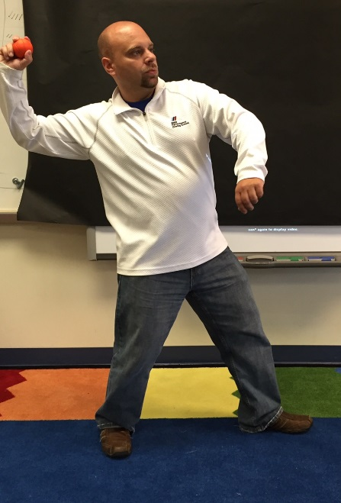 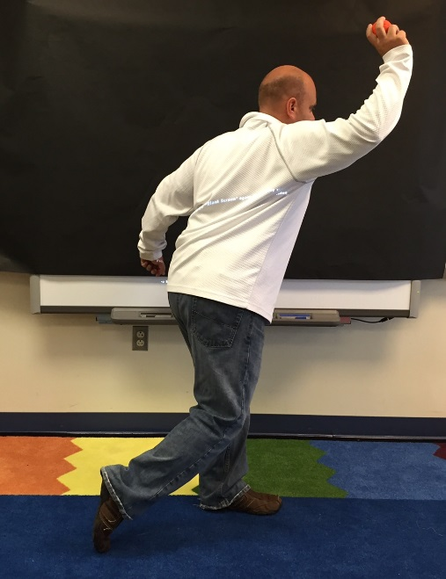 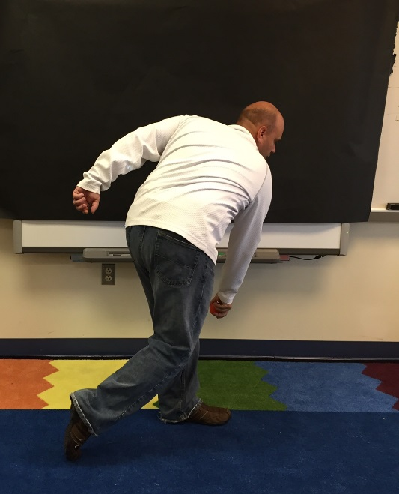

Scoring

Using the above cards, students will put all 4 critical cues of the overhand throw in sequential order.