Pennsylvania Health and Physical Education PreK-12 Knowledge and Skills-Based Outcomes

Training Manual

About the Authors

Dr. Cindy Allen, Emeritus Lock Haven University professor, retired from the college in 2017 with 24 years of teaching as well as teaching 14 years in public schools. In 2015, Dr. Allen obtained her Superintendent’s Letter of Eligibility. Her responsibilities while at the university included teaching undergraduate and graduate courses in both the Department of Health and Physical Education and in the Department of Health Sciences. Dr. Allen served as PSAHPERD’s President in 2013 and received PSAHPERD’s highest recognition, the Elmer B. Cottrell Award, the Elementary Teacher of the Year, and the University Health Education Teacher of the Year. She also received the Professional Honor Awards for both PSAHPERD and SHAPE’s Eastern District as well as Eastern District’s Linda Woods Huber Award in 2019. She is one of the writers for the new PA Academic Standards and Outcomes as well as working on the new professional training and the Assessment Tool kit to accompany the new Standards and Outcomes.

Dr. Jennifer V. Butz is an elementary physical education teacher at Northern Lehigh School District and has been teaching for 15 years. She is on the PDE Health and Physical Education Professional Improvement Committee and serves on the SHAPE PA Board of Directors. She completed her undergraduate degree at Lock Haven University of Pennsylvania in the Health and Physical Education Program. Her master’s degree is in Classroom Technology from Wilkes University. Her doctorate degree in Curriculum and Instruction was completed at Indiana University of Pennsylvania.

Jeff Jacobs recently retired from the Methacton School District where he taught elementary Health and Physical Education and served as the K-6 HPE Coordinator and K-12 Department Chair. Prior to that, he served as the Assistant to the Headmaster, and Health and Physical Education Department Chair, at The Shipley School. Jeff continues to be very active in the field by contributing to the proposed PA State HPE Academic Standards and Outcomes, advocating for HPE, and presenting workshops. His website, JeffJacobsHPE.com, provides up-to-date information in many areas of Physical Education. Jeff has been the recipient of numerous awards including the SHAPE America District Teacher of the Year (Eastern District).
Dr. Kimberley A. Razzano is a professor and Department Chair for the Department of Health Studies at East Stroudsburg University. Her responsibilities include serving as department chair, teaching graduate and undergraduate courses in pedagogy, sexuality, and disease prevention. She was PSAHPERD president in 2012, Ethel Encke Service Award winner in 2016, and Elmer B. Cottrell Award winner in 2018. She has received TOY, Professional Honor Awards for both SHAPE PA and EDA. In 2021, she received the Linda Woods Huber Award for EDA. Presently, she is one of the writers for the New Pennsylvania Health Physical Education State Standards and Assessment Tool Kit. Her most memorable area of service was during her presidential year for PSAHPERD in 2012 and again in 2013. The Capital to Capitol ONE Ride was a 153-mile cycle trip from Harrisburg PA to our nation’s Capital. Between both rides over 20,000 dollars was raised and is now being used for schools and community agencies to apply for grants to implement physical activity and healthy eating programs toward obesity prevention.

Dr. Jennifer L Rudella is currently an Associate Professor at Lock Haven University of Pennsylvania in the Department of Health Science and has been teaching in higher education for over seven years. Her teaching career began in public education where she taught elementary physical education, adapted physical education, high school health education, high school physical education, and lifetime fitness for five years. Her Pennsylvania licenses include an Instructional II teaching certification in health and physical education and a Supervisory certification in PreK-12 curriculum and instruction. She is also a Certified Health Education Specialist from the National Commission for Health Education Credentialing, Incorporated. Dr. Rudella completed her undergraduate degree at Lock Haven University of Pennsylvania in the Health and Physical Education program. Her master’s degree in Exercise Science and Health Promotion was acquired from the California University of Pennsylvania. Her doctoral degree in Curriculum and Instruction was completed at the Indiana University of Pennsylvania.

Nicholas Slotterback is the Health and Physical Education Advisor at the Pennsylvania Department of Education. He graduated from Lock Haven University and received his Master’s Degree in Education. Nick taught elementary and middle school health and physical education from 2005 to 2016 in the Midd-West School District where he also served as the Curriculum Coordinator of Health and Physical Education. In addition to teaching, Nick coached JV basketball at Midd-West and Lewisburg Area School District as well as Varsity Track and Field at Lewisburg Area School District. Nick also served as an Educational Consultant for Playworld Play Systems from 2006 to 2018.

Table of Contents

Agenda

Agenda for Participants Page 1

Power Point Presentations

Introduction Page 2

Health Education Outcomes Overview Page 21

Physical Education Outcomes Overview Page 27

Templates with Directions

Scope and Sequence: Health Education Page 33

Scope and Sequence: Physical Education Page 35

Block Plan Page 37

Lesson Plan Page 39

Template Examples

Elementary Health Scope and Sequence Page 41

High School Physical Education Lesson Plan Page 43

Elementary Health Block Plan: 4th Grade Alcohol and Other Drugs Page 46

Middle School Health Block Plan: 7th Grade Tobacco Page 51

High School Health Block Plan: 11th Grade Mental Health Page 56

Elementary Physical Education Block Plan: Kindergarten Locomotor Movement Page 59

Middle School Physical Education Block Plan: 7th and 8th Grade Dance Page 63

High School Physical Education: 10th Grade Weight Training Page 67

Blank Templates for Participants
Health Scope and Sequence Page 72
Physical Education Scope and Sequence Page 74
Block Plan Page 76
Lesson Plan Page 78

Training Evaluation

Understanding the Outcomes Training Evaluation Form Page 80

Curriculum Mapping/Development Evaluation Form Page 81

Assessment Development Evaluation Form Page 82

Contact Information

HPE PIC Committee Members and Professional Trainers Page 83

Agenda for Participants
9:00 am Welcome – Introductions - Overview of the Training

Session 1 Introduction to PA Health and Physical Education
PreK-12 Knowledge and Skills-Based Outcomes - Power Points 101/SAS

Break - 10 minutes

Session 2 Health and Physical Education- Outcomes Side-by-Side –
Health & PE PowerPoints

Q/A

Separate into Health Education and Physical Education Subject Areas
- Introduce Scope/Sequence Template

- Explain How to Build a Scope & Sequence

(Partners/groups of three start to write one)

Lunch

Together - Quick Review of Morning- If needed, provide extra time to complete the Scope and Sequence form. Participants share their Scope and Sequence with the group.

Session 3 Separate groups:

- Introduce Block Plan Template - Compare with S/S completed form
- Create a Block Plan consisting of 3or more lessons- working in pairs/groups of three

Break 10 minutes

Session 4 Separate groups:

- Introduce Lesson Plan Template - share examples

- Participants transfer one of their Block Plans onto the Lesson Plan Template

(Could finish the lesson plan on their own and send to trainers for feedback for next day or next session)

Q/A, Closure, Evaluation of session

3:30 pm Depart

Introduction Power Point Slides
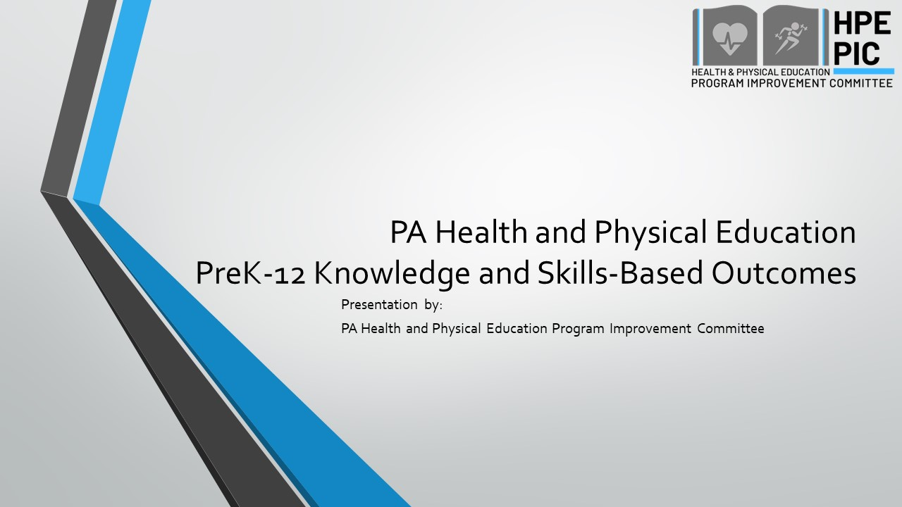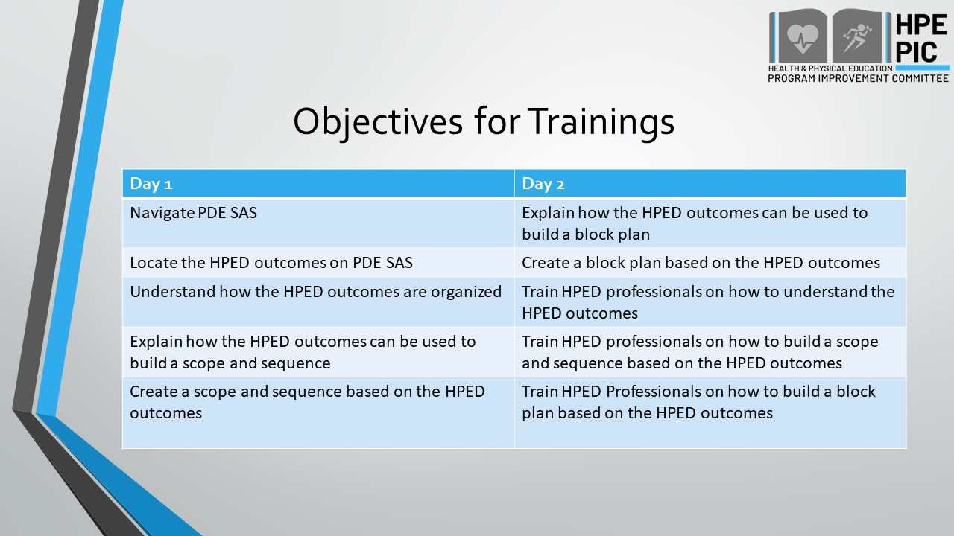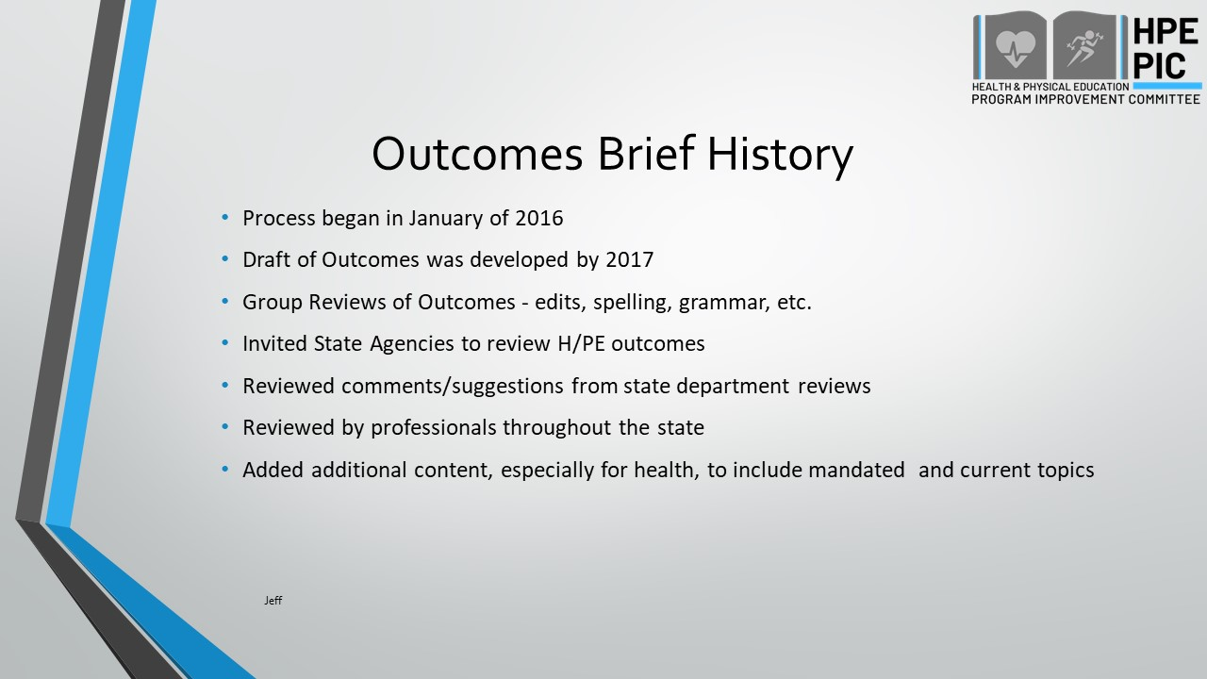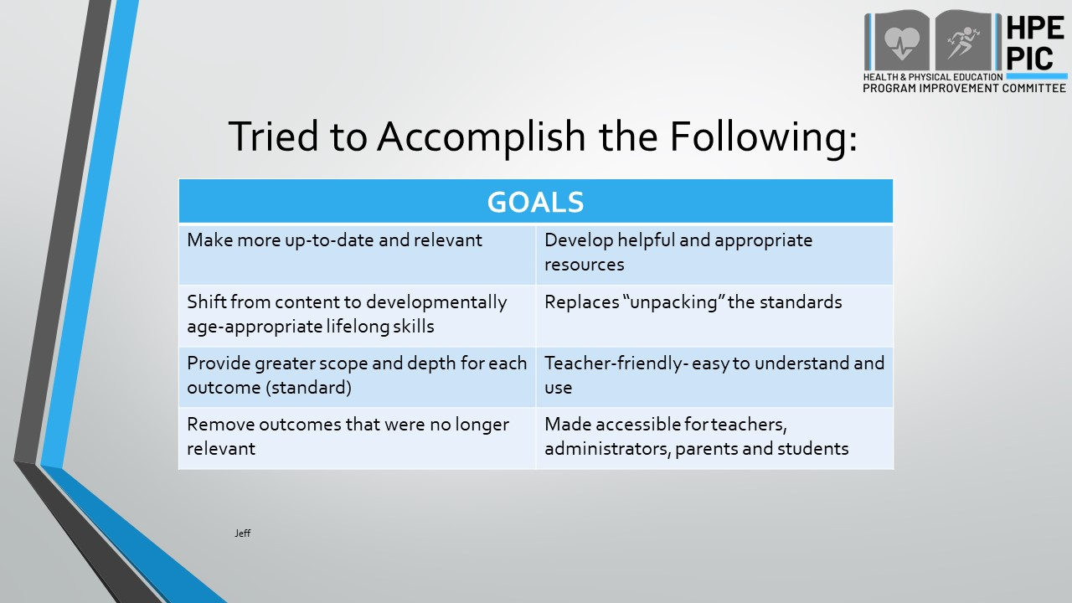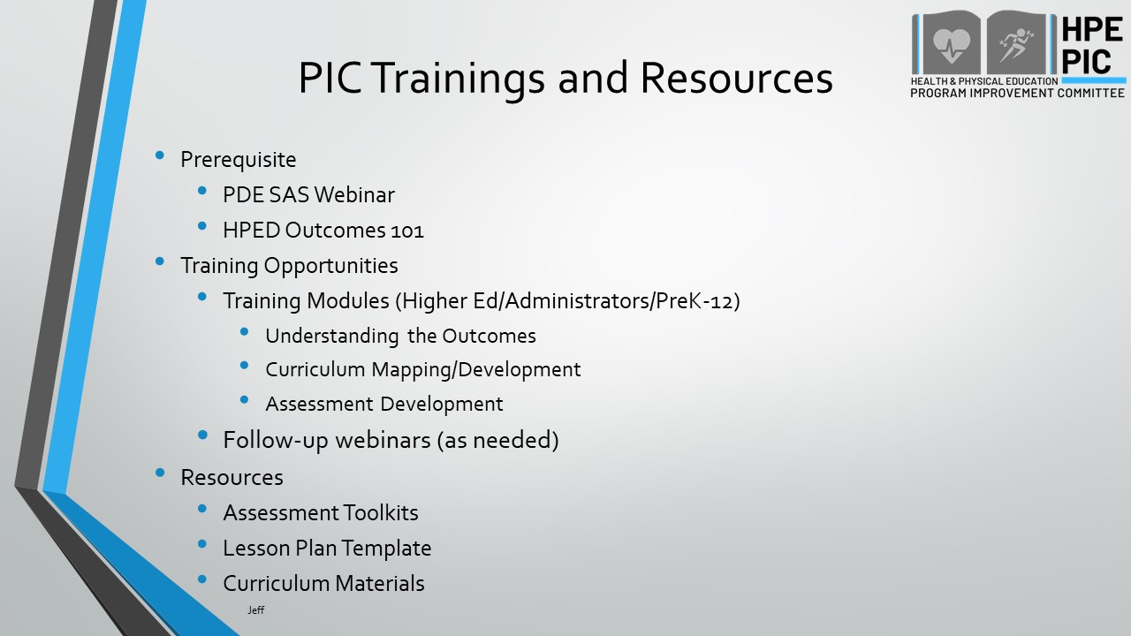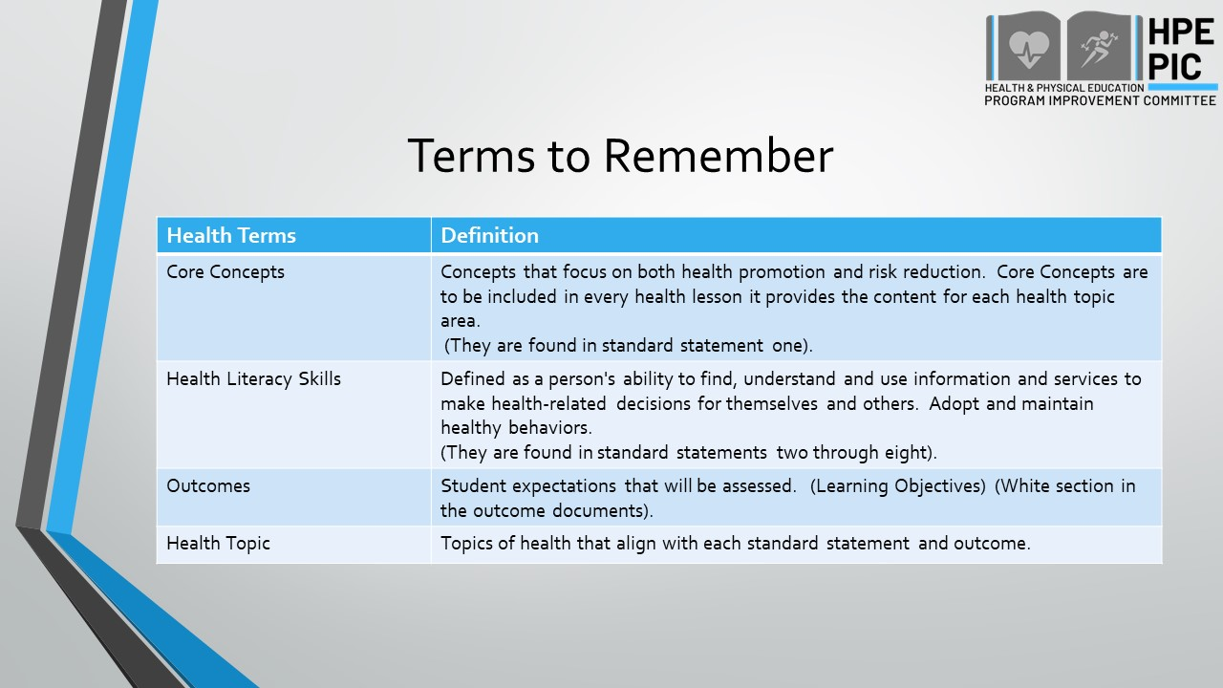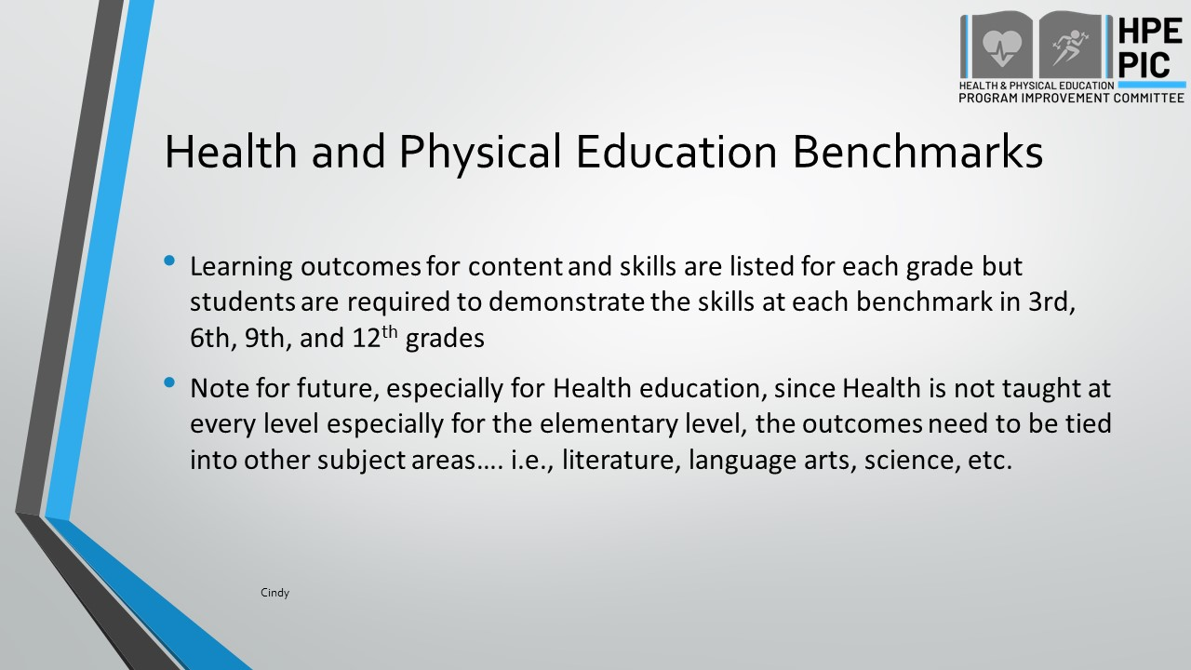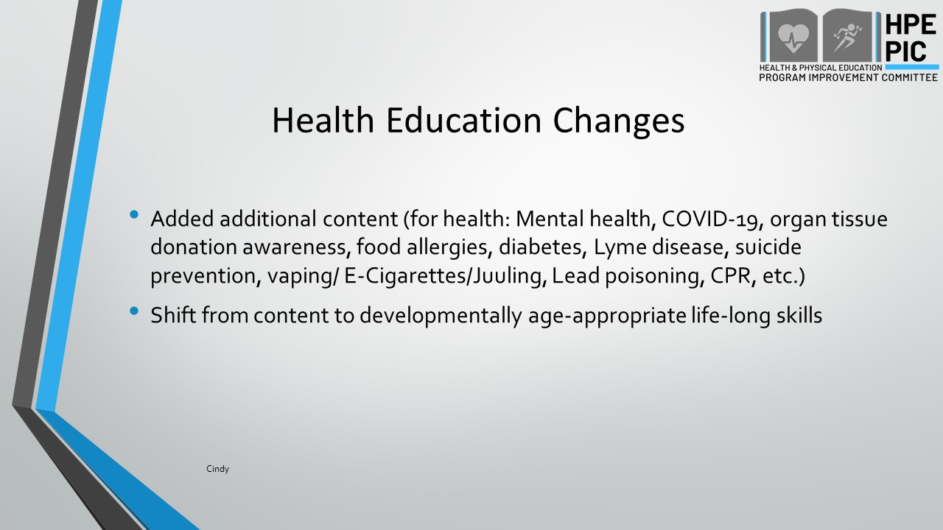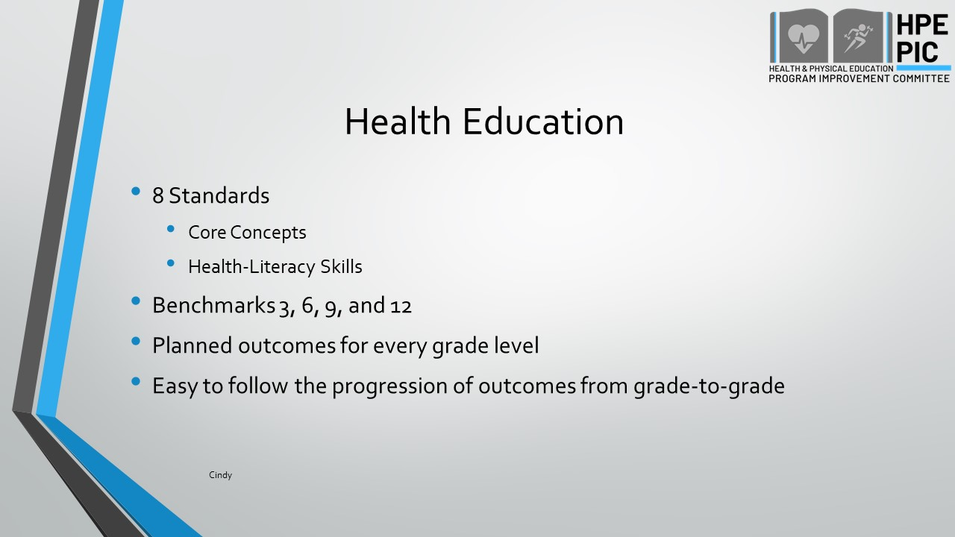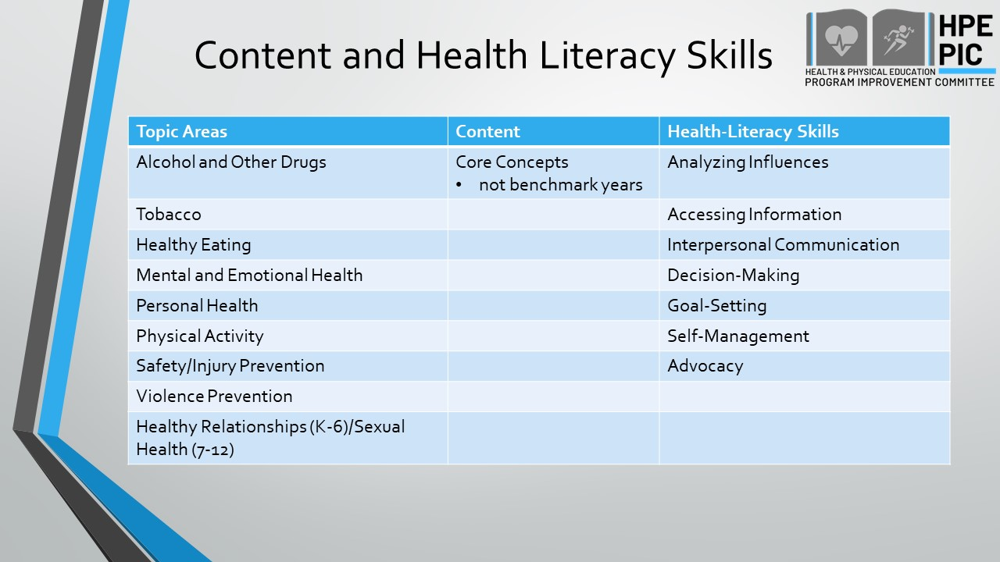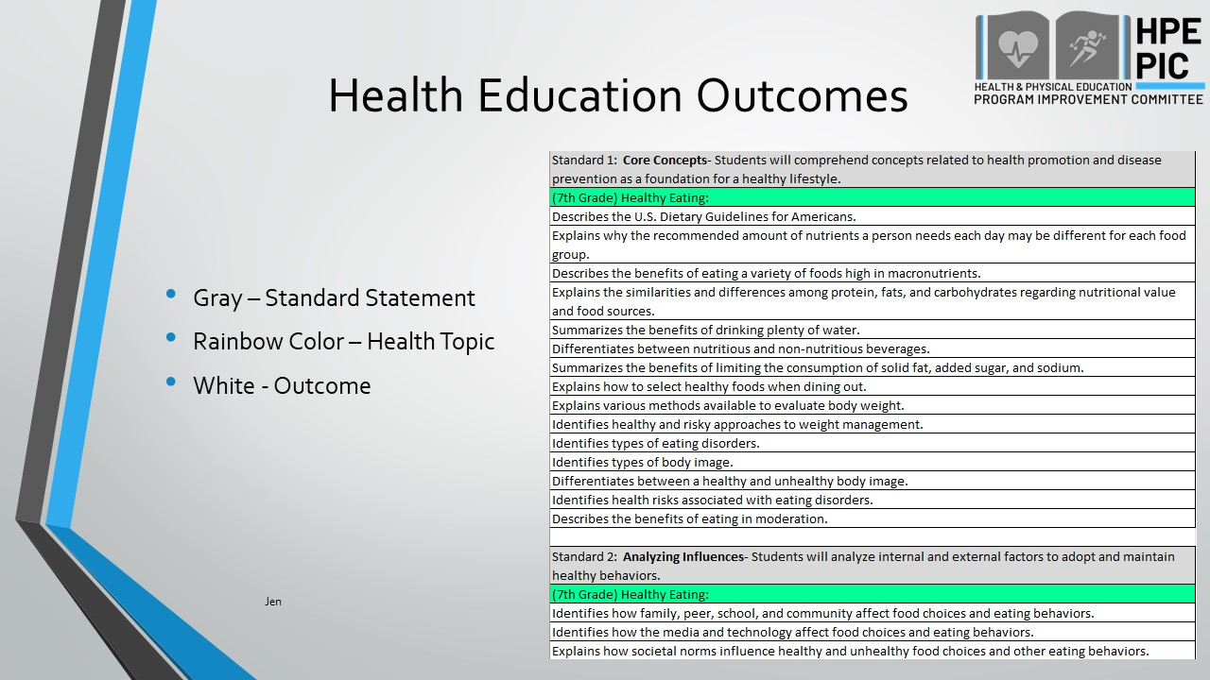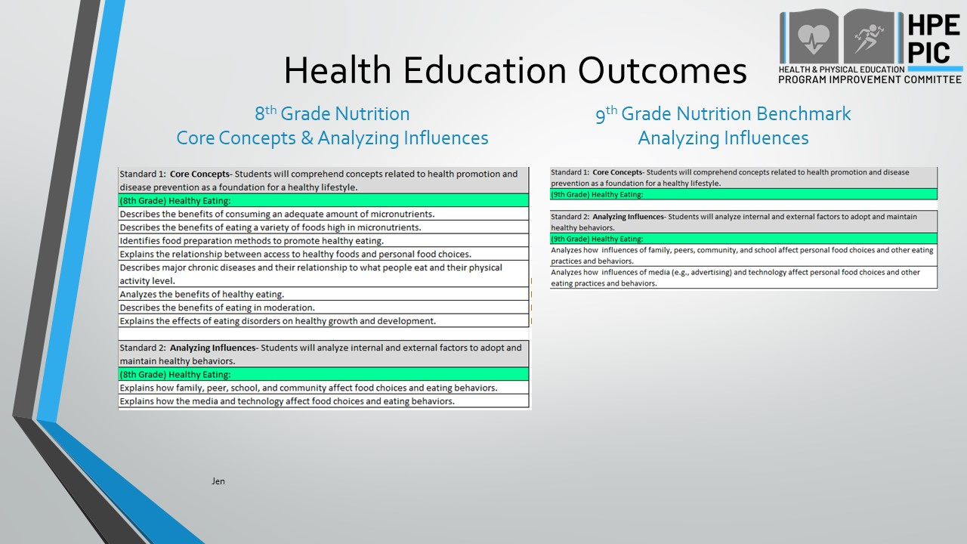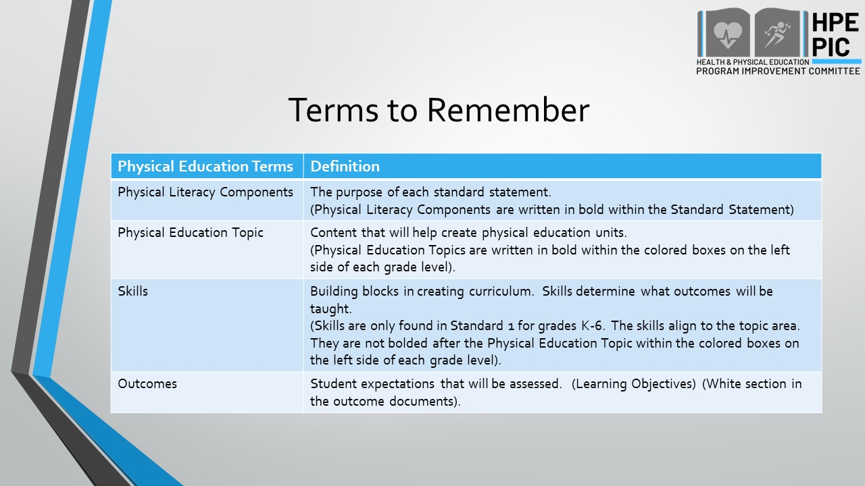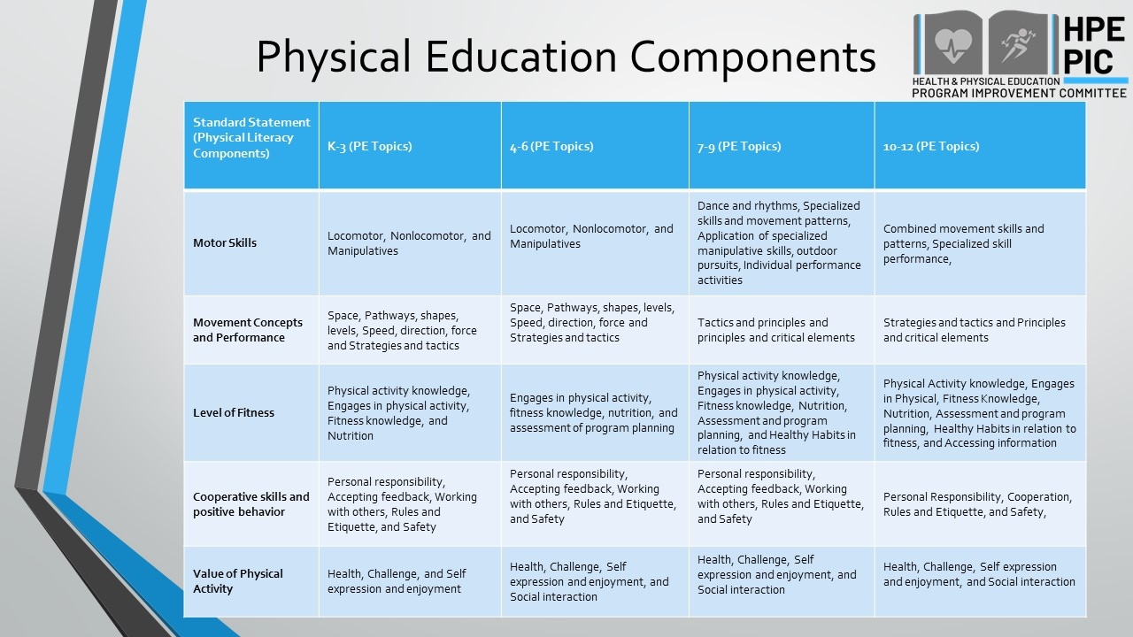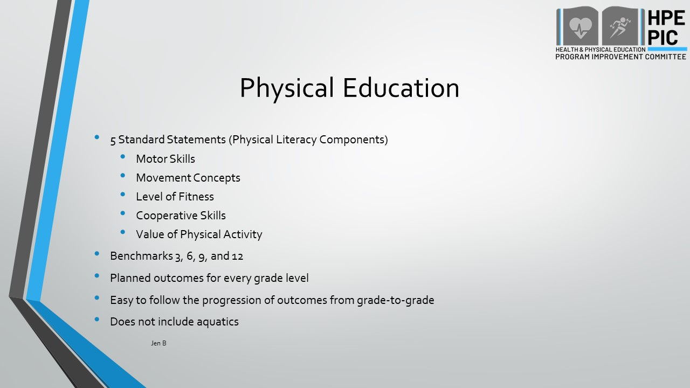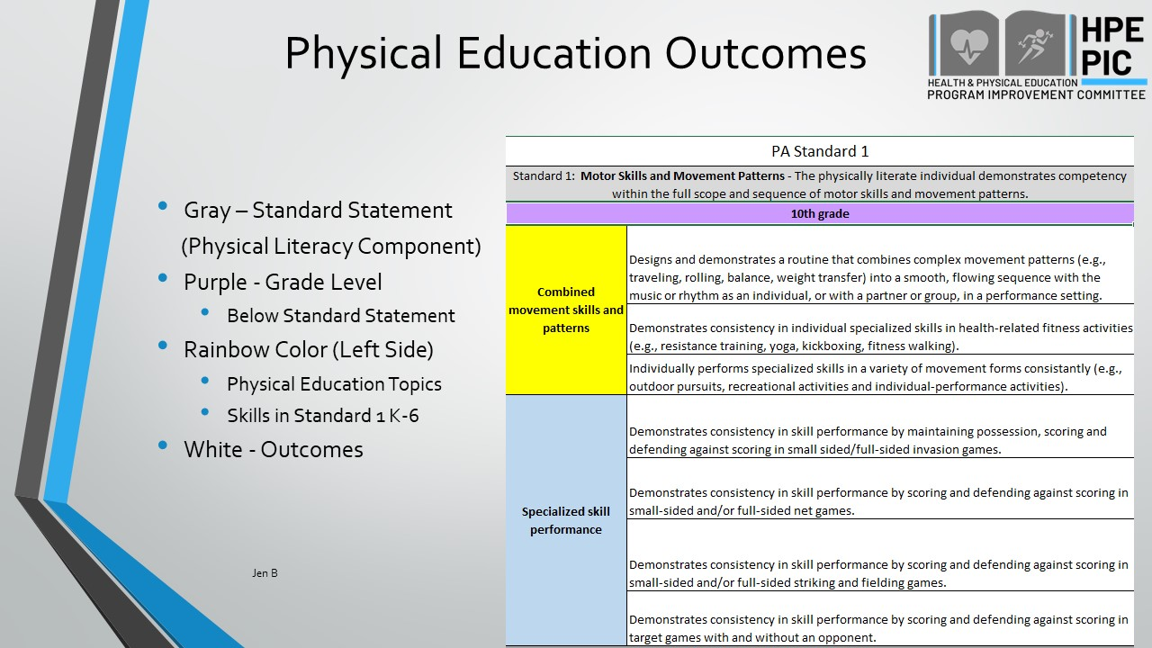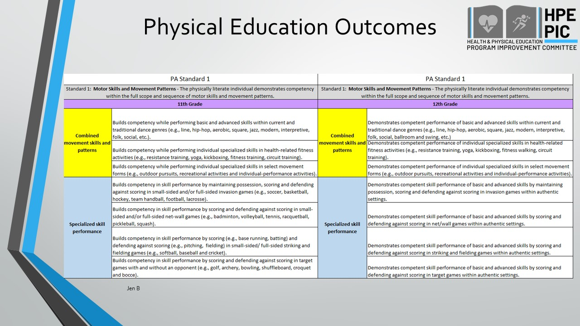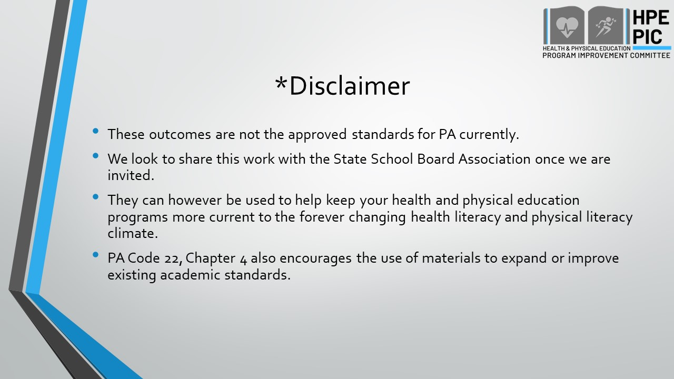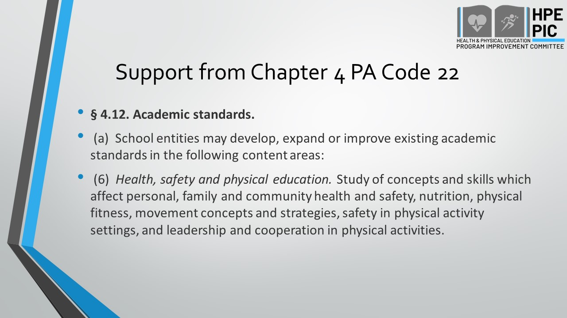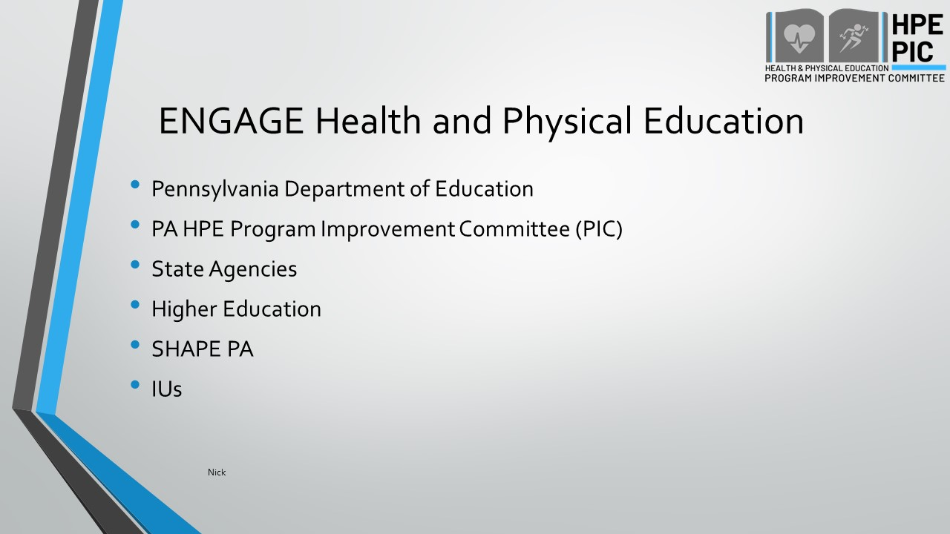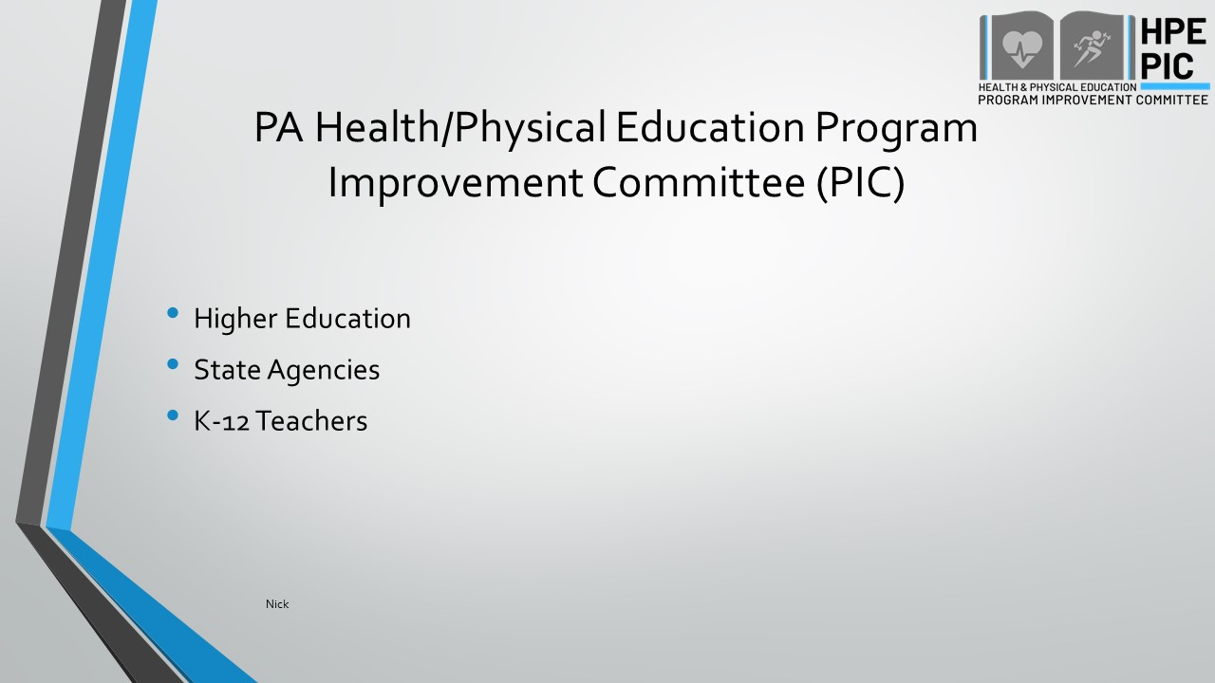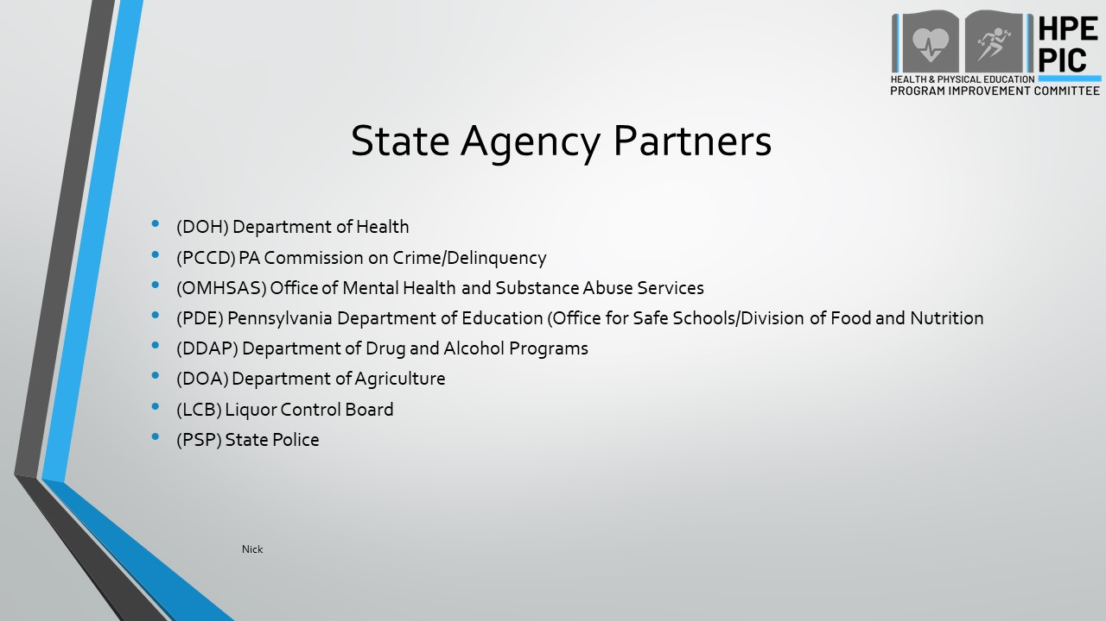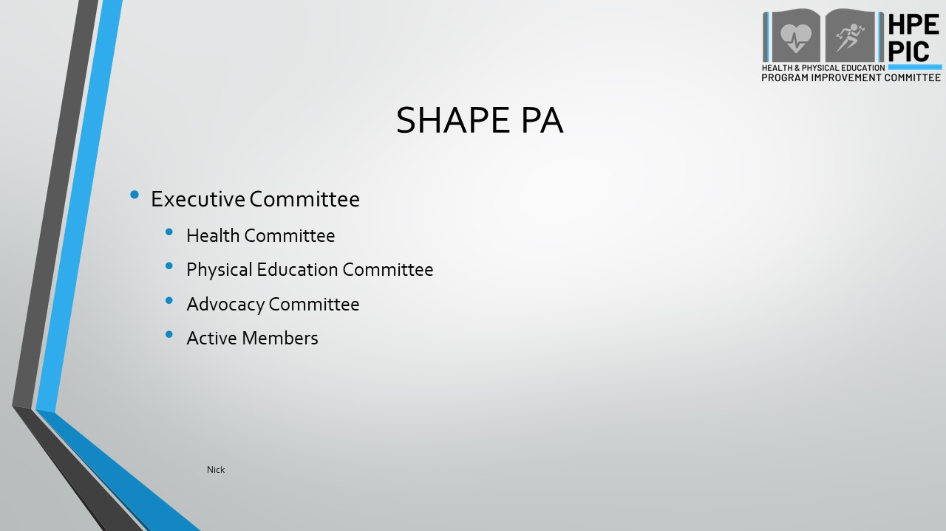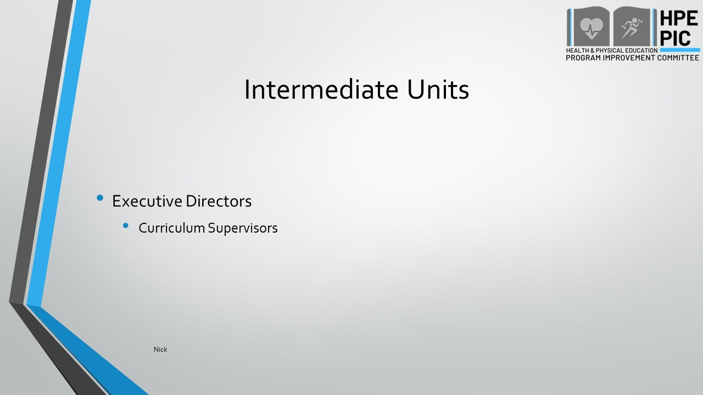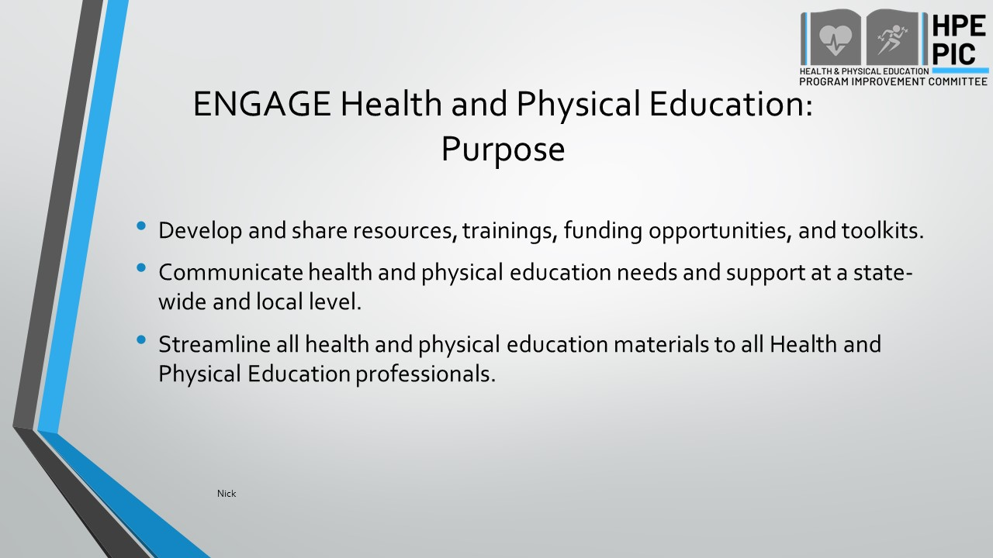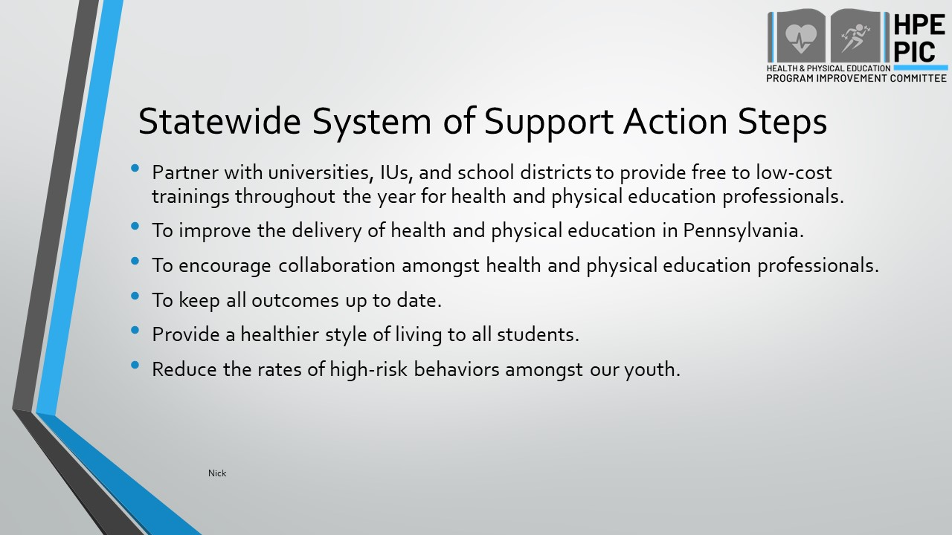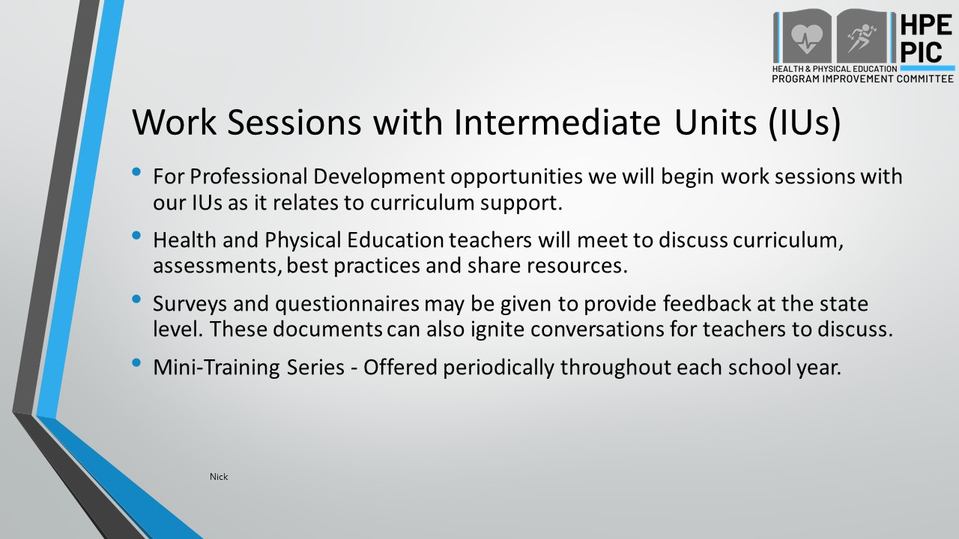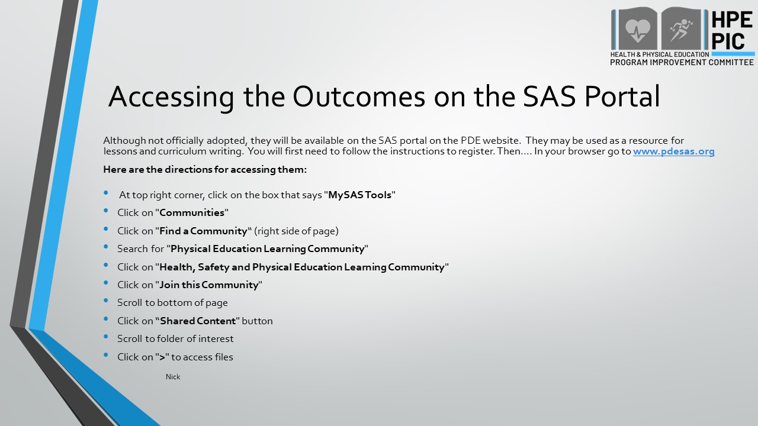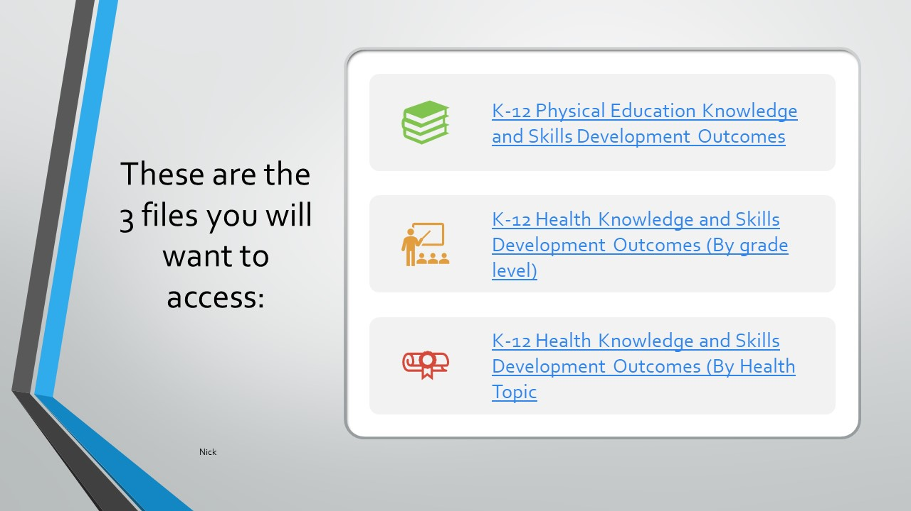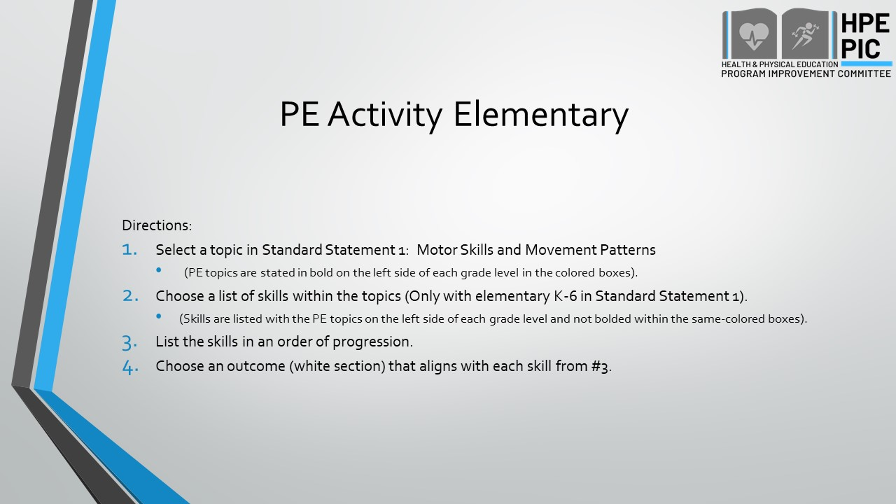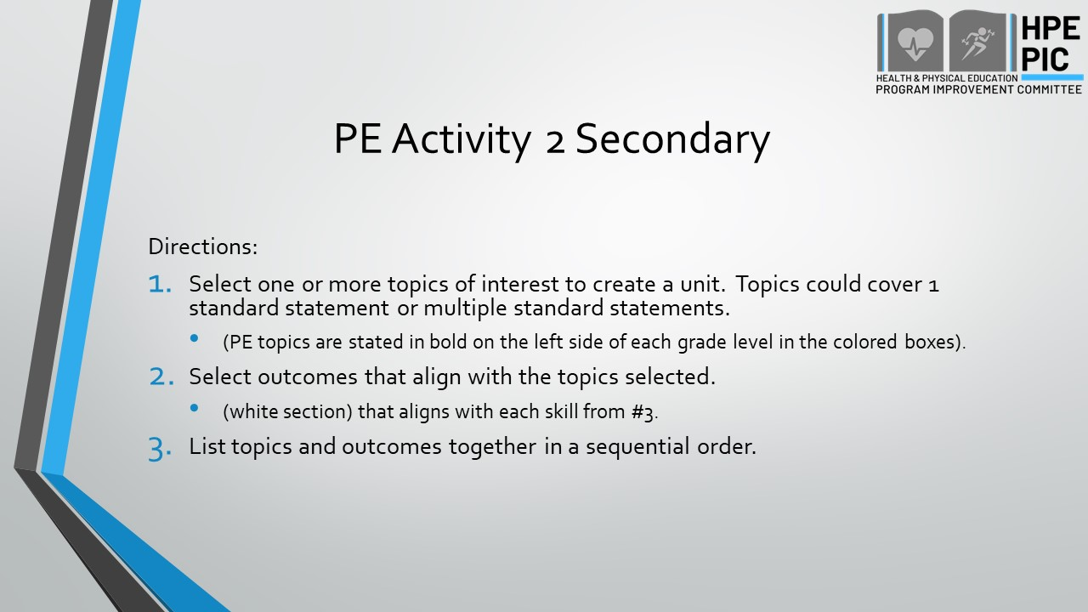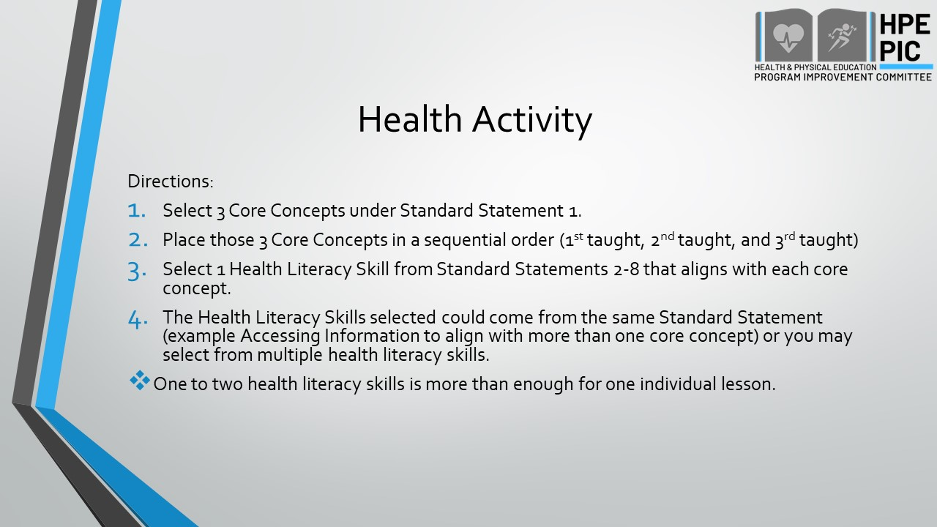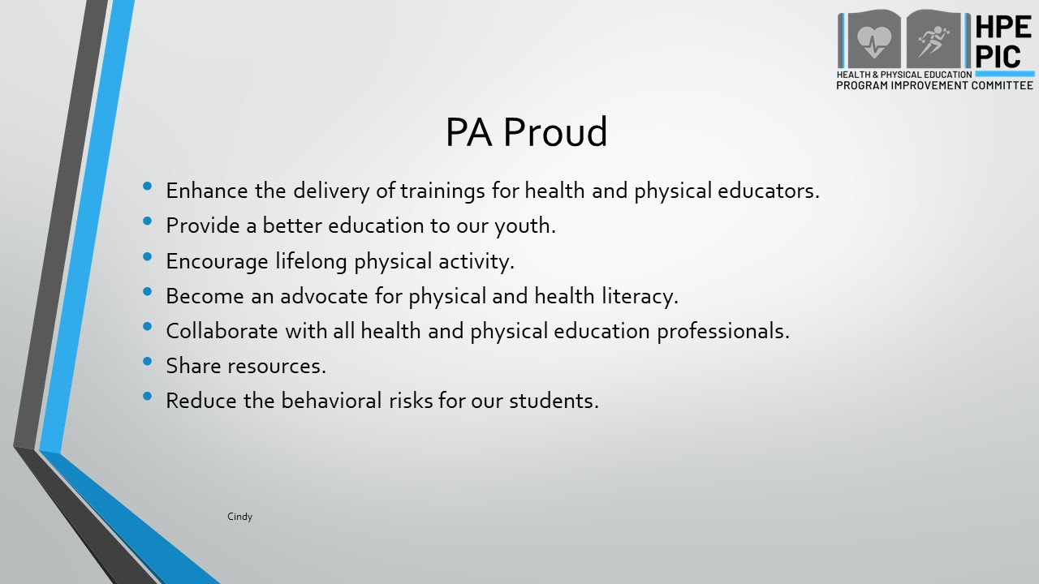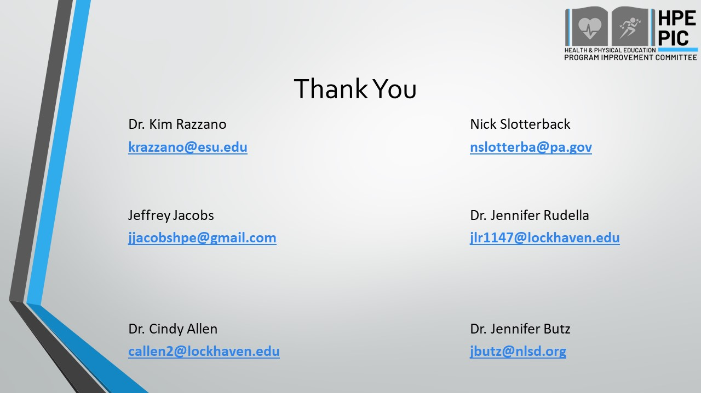

Health Education Outcomes Overview Power Point Slides
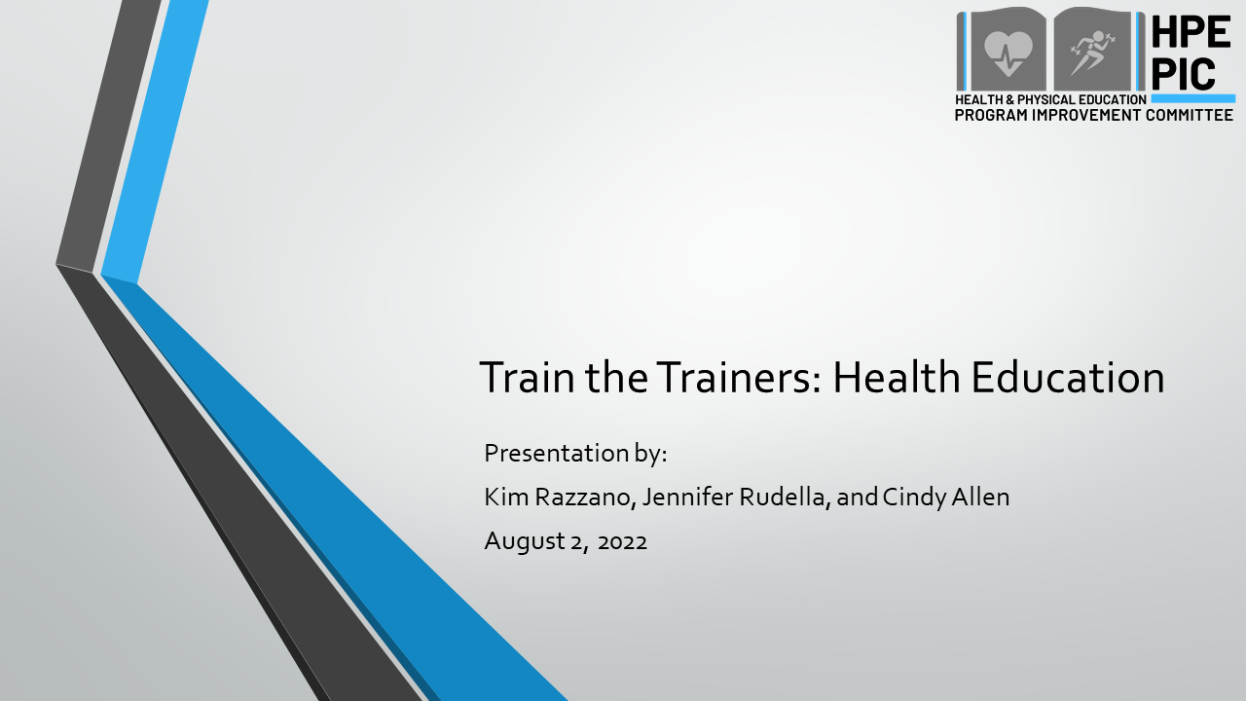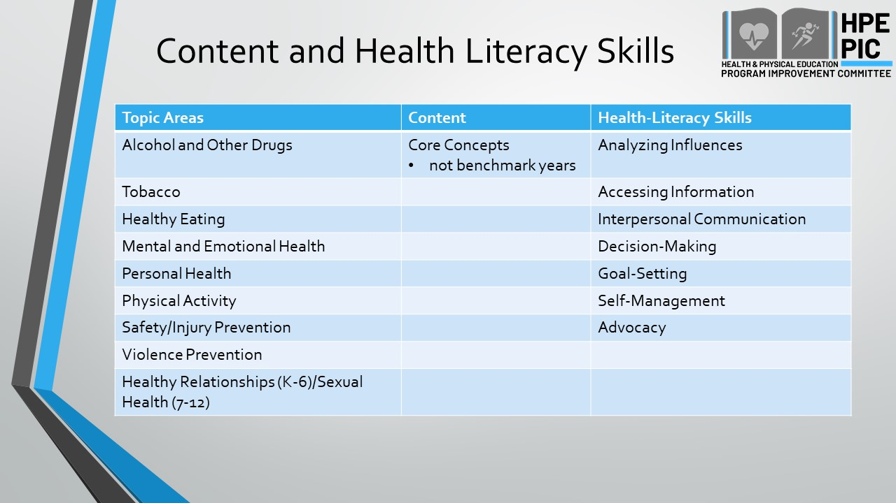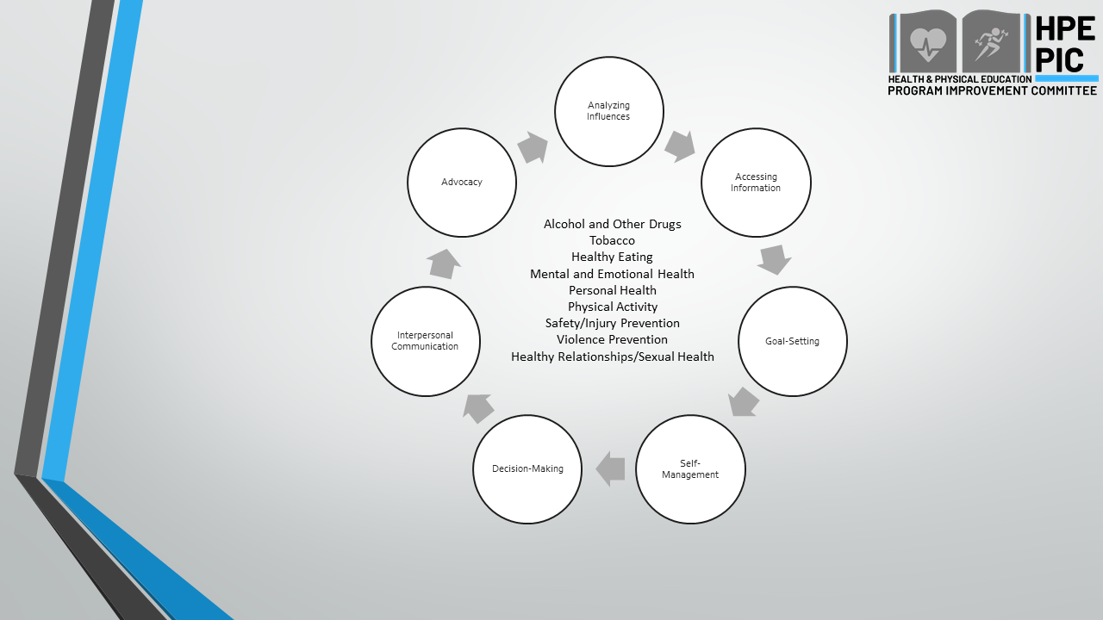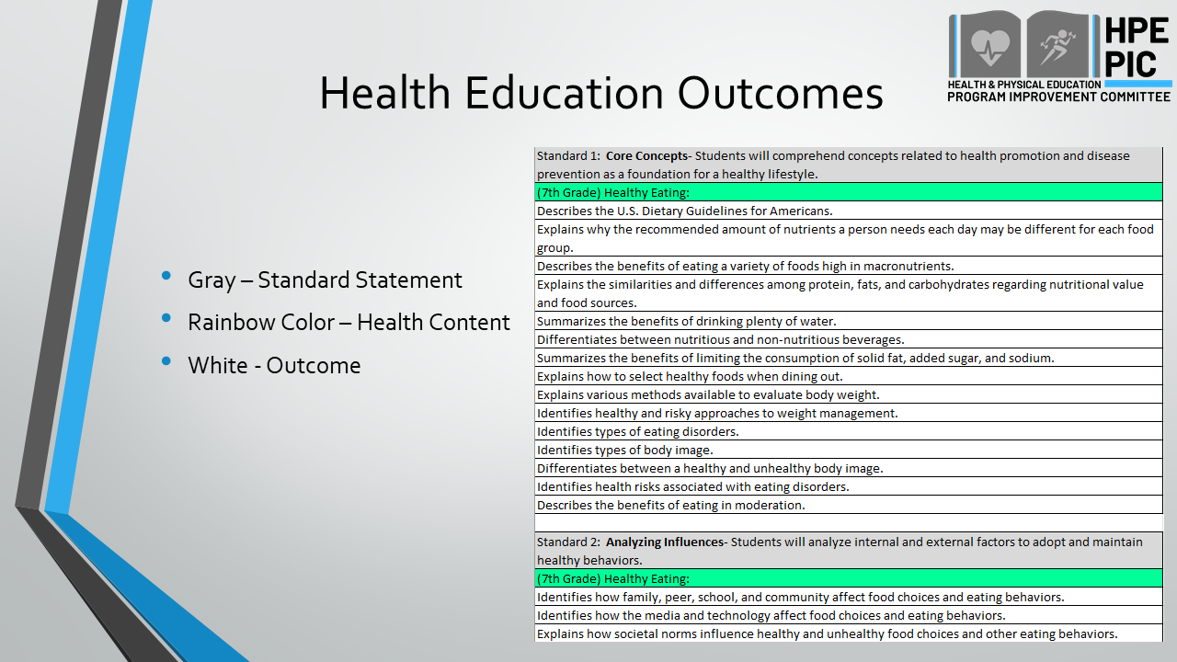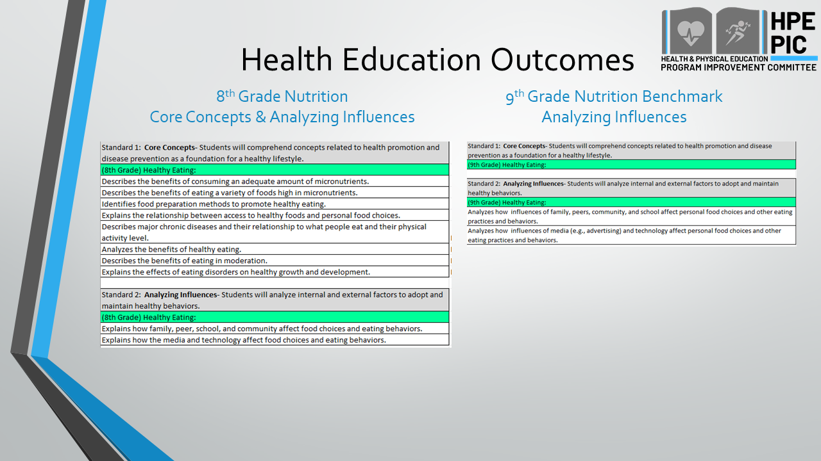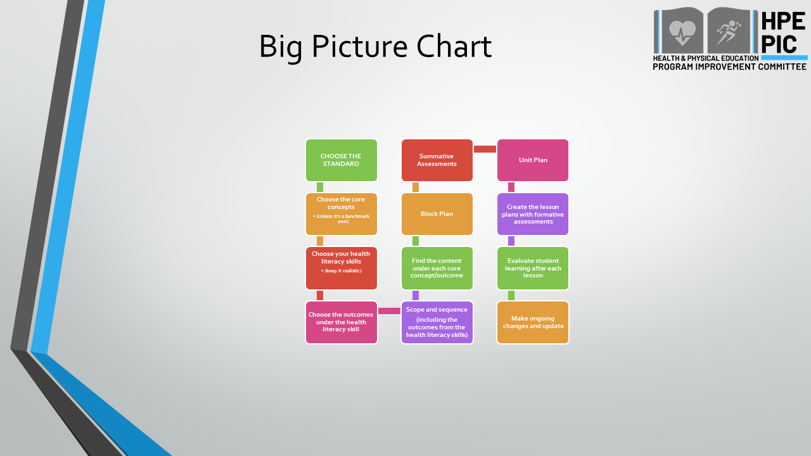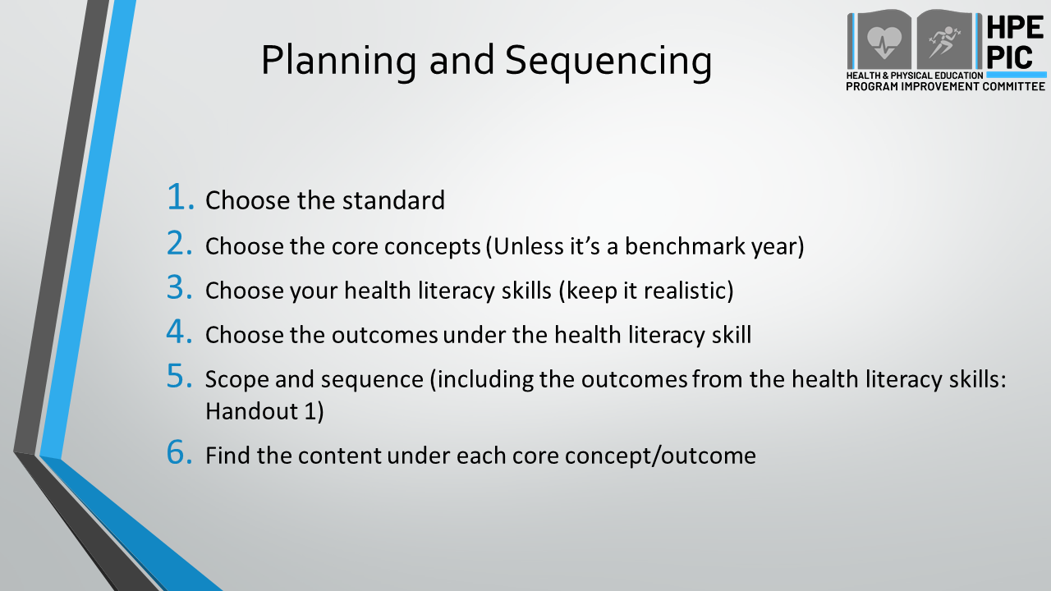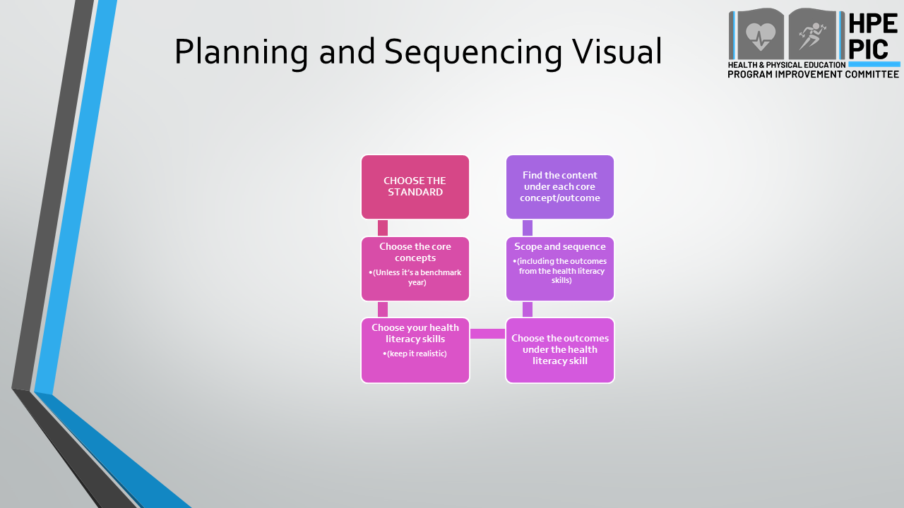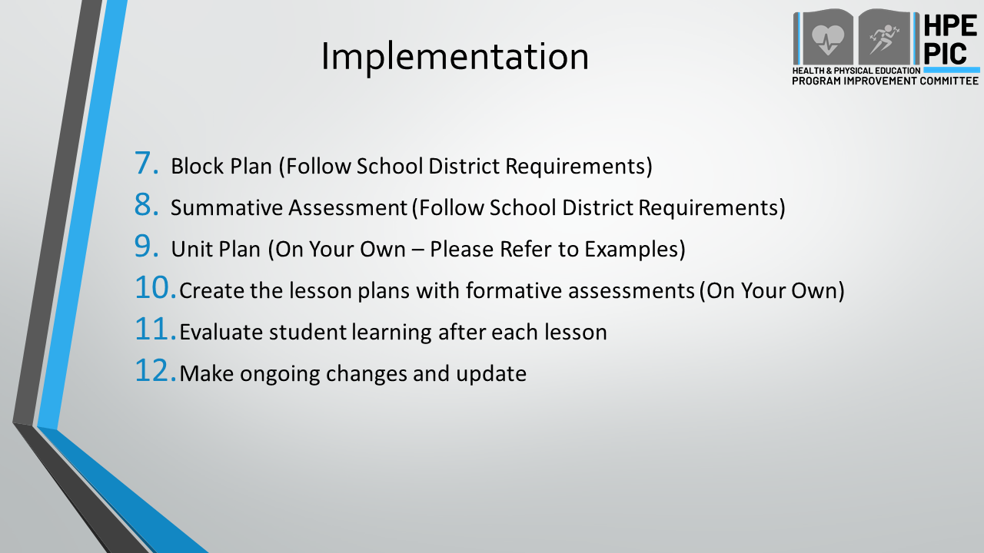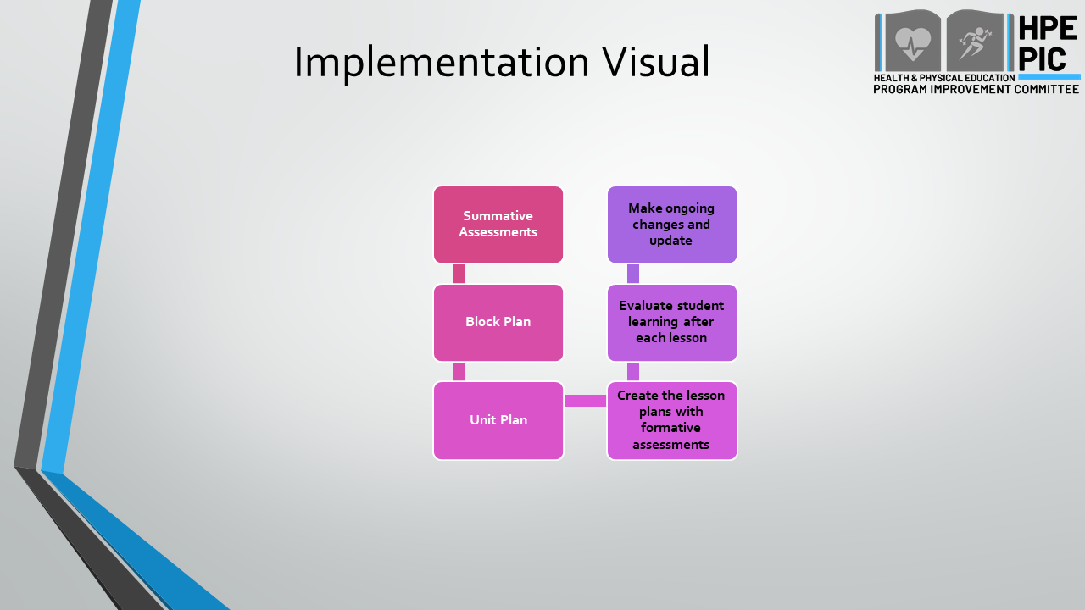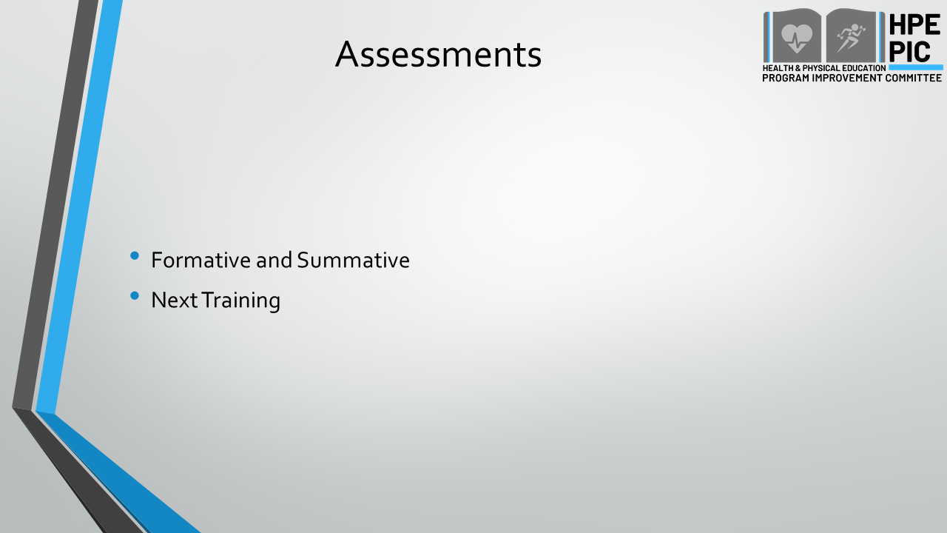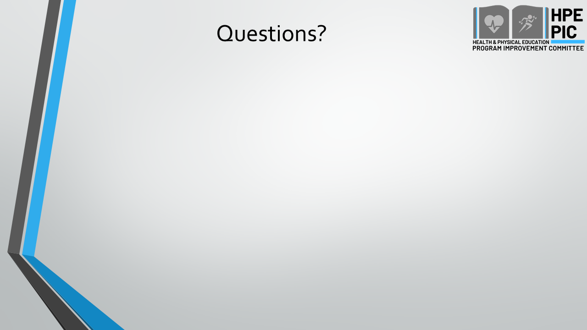

Physical Education Outcomes Overview Power Point Slides
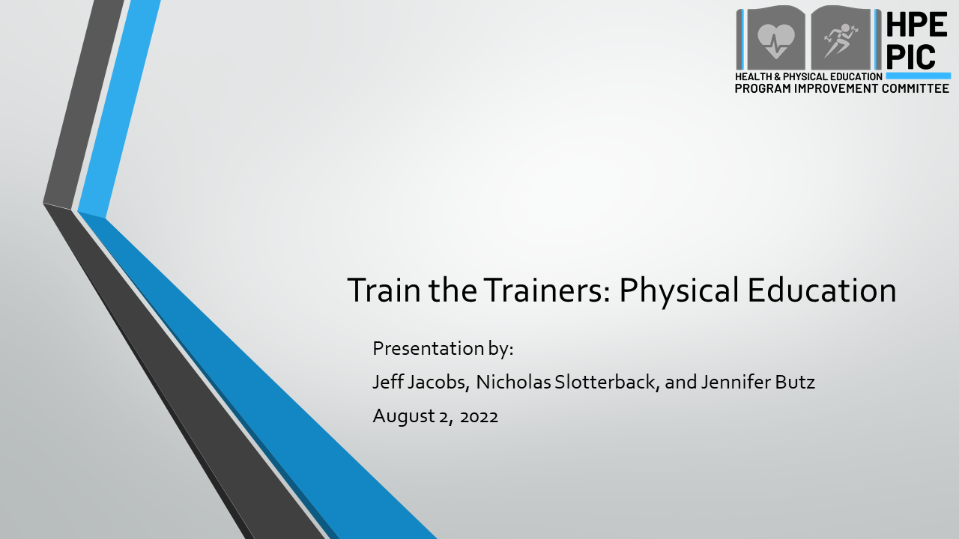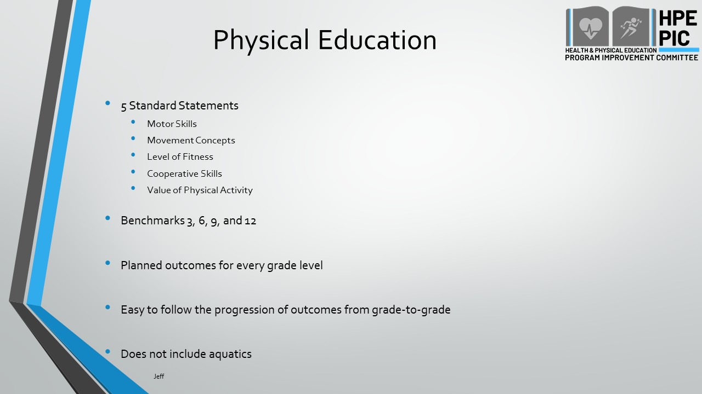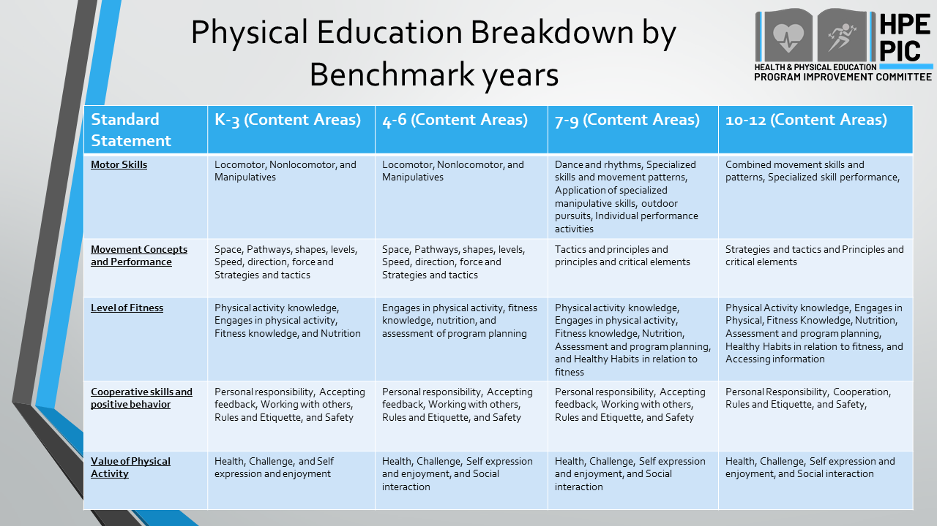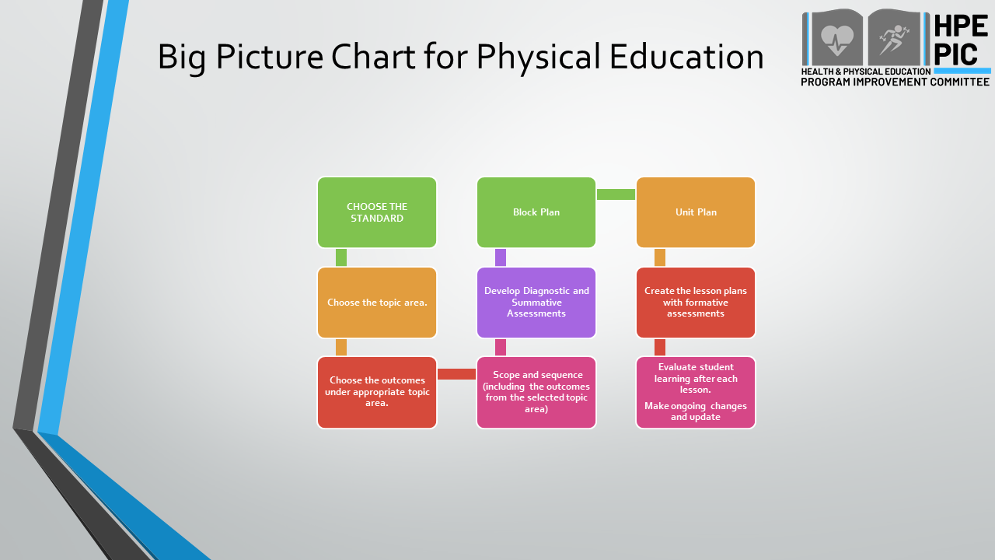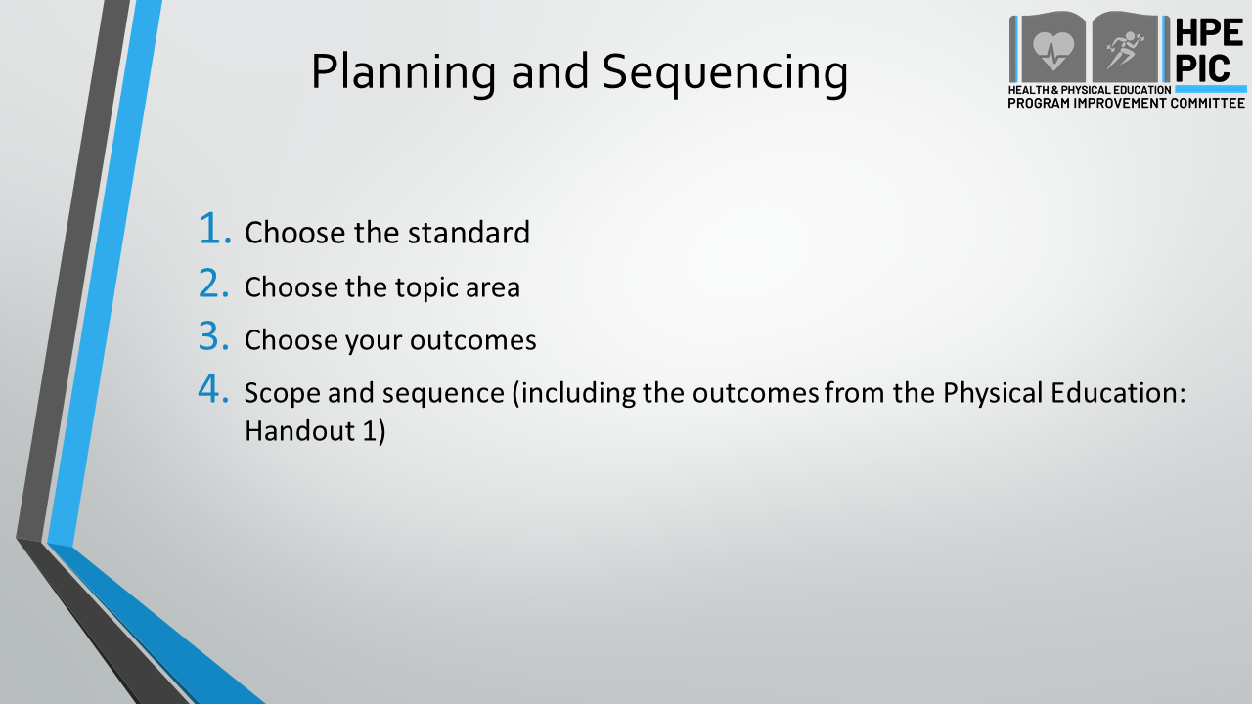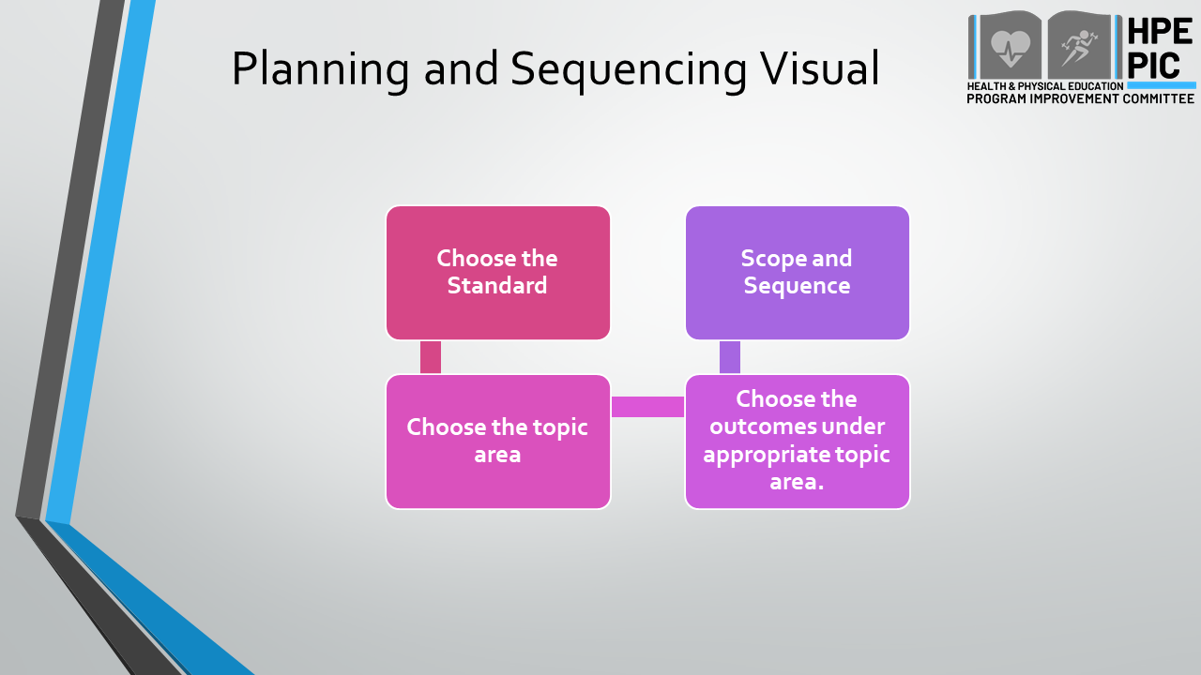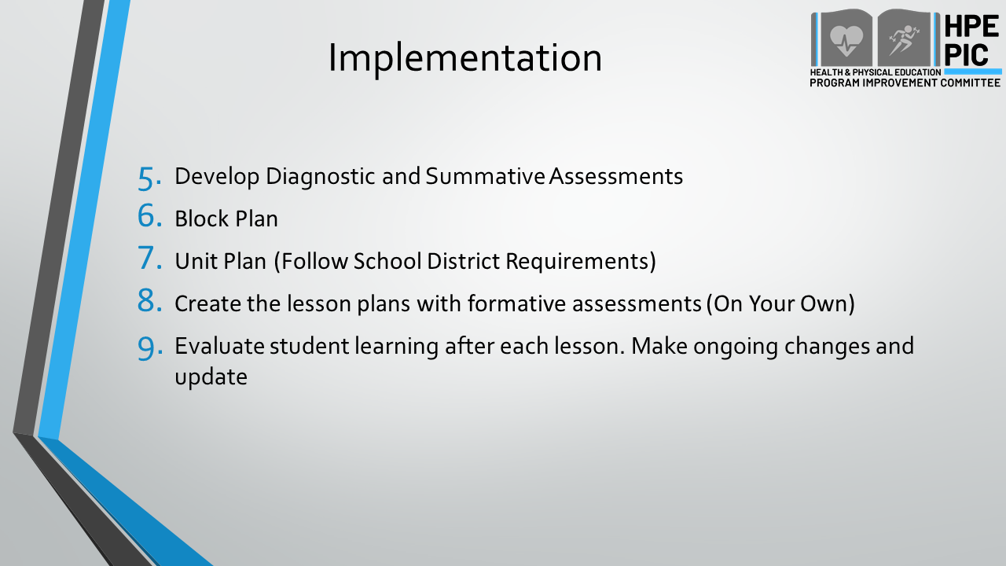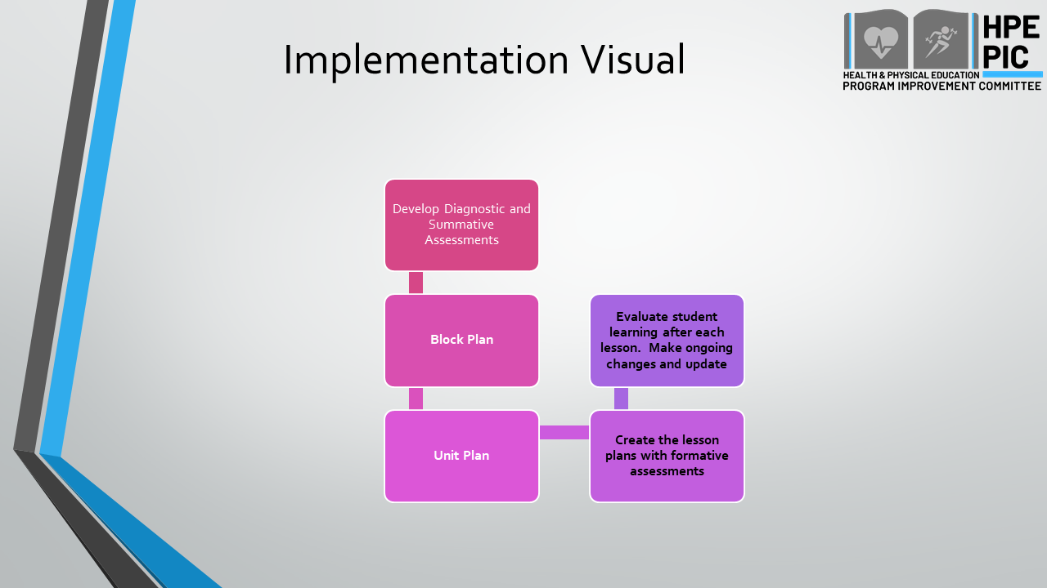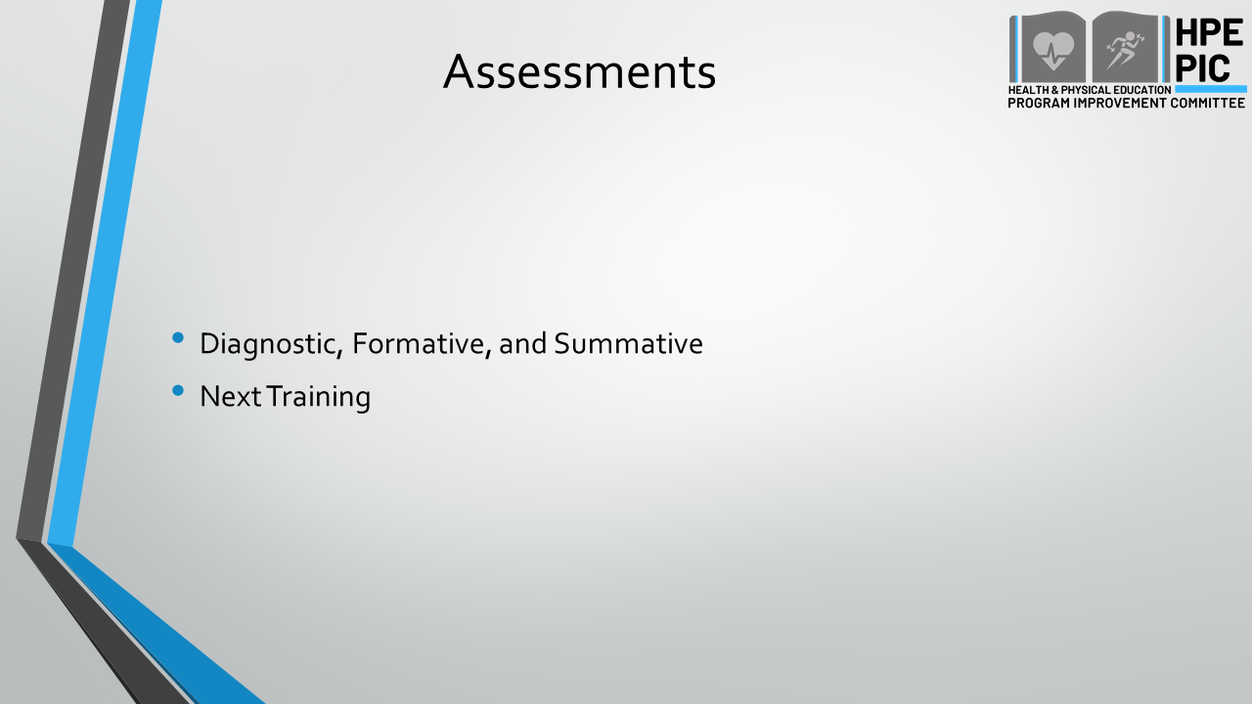

Scope and Sequence
Health Education

- Grade Level(s)

- Choose the Content Area:

- Choose the Standards (Standard Numbers):

- Choose Core Concepts Outcomes:

- Choose Health Literacy Skill Outcomes (List Health Literacy Skill for Each Outcome – Be Realistic):
Health Literacy Skill | Health Literacy Skill Outcomes

- Scope & Sequence Core Concepts and Skill Outcomes – Sequencing Numbers 4 and 5:
Lesson A
Core Concept Outcomes

Health Literacy Skill Outcomes

Lesson B
Core Concept Outcomes

Health Literacy Skill Outcomes

Lesson C
Core Concept Outcomes

Health Literacy Skill Outcomes

Lesson D
Core Concept Outcomes

Health Literacy Skill Outcomes

- Assessments: How do we know whether this student was successful?

Formative:
Summative:

Scope and Sequence
Physical Education
- Grade Level:

- Choose the Standard(s) (Standard Number):

- Choose the Content Area:

- Choose Outcomes (List all Outcomes for each lesson – Be Realistic):

- Scope & Sequence of Skill-Based Outcomes & Activity for each lesson:
Lesson 1 Outcome(s) | Lesson 1 Activity

Lesson 2 Outcome(s) | Lesson 2 Activity

Lesson 3 Outcome(s) | Lesson 3 Activity

Lesson 4 Outcome(s) | Lesson 4 Activity

Lesson 5 Outcome(s) | Lesson 5 Activity

Lesson 6 Outcome(s) | Lesson 6 Activity

- Assessment of Skill-Based Outcomes: How do you know the student was successful?

Formative:
Summative:

Block Plan
Health and Physical Education
GRADE LEVEL(S):
TOPIC:
STANDARD NUMBERS:
Lesson #1
Lesson Title:
Health and/or Physical Education Outcomes:
Content (Teacher Discussion Outline):
Strategies/Activities:
Diagnostic Assessment (Pre-Test):
Formative Assessments:

Lesson #2
Lesson Title:
Health and/or Physical Education Outcomes:
Content (Teacher Discussion Outline):
Strategies/Activities:
Formative Assessments:

Lesson #3
Lesson Title:
Health and/or Physical Education Outcomes:
Content (Teacher Discussion Outline):
Strategies/Activities:
Formative Assessments:

Lesson #4
Lesson Title:
Health and/or Physical Education Outcomes:
Content (Teacher Discussion Outline):
Strategies/Activities:
Formative Assessments:

Lesson #5
Lesson Title:
Health and/or Physical Education Outcomes:
Content (Teacher Discussion Outline):
Strategies/Activities:
Formative Assessments:

Lesson #6
Lesson Title:
Health and/or Physical Education Outcomes:
Content (Teacher Discussion Outline):
Strategies/Activities:
Formative Assessments:

Summative Assessments

Health and Physical Education Content:
Diagnostic Assessment (Post-Test):
Performance-Based Assessment:

Lesson Plan
Health and Physical Education
- Unit Topic:

- Lesson Title:

- Grade Level:

- Standards/Learning Outcomes (Health and/or PE)
  - Standards:

  - Outcomes:

- Assessment
  - Diagnostic, Formative or Summative:

- Instructional Outline
- Introduction:
- Content Outline:

- Learning Strategies and Activities:
  - Skill Development
    - *Explain Importance of the Skill:

    - Demonstrate Skill Steps:

  - Skill Application
    - Provide adequate time to demonstrate and practice skill:

    - Formative assessments:
- Closure:

- Modifications/Extensions:
- *Vocabulary:
- *Materials:
- *Resources:
*Use as needed

Scope and Sequence Example
Health Education

- Grade Level(s)
Kindergarten

- Choose the Standards (Standard Numbers):
1, 5

- Choose the Content Area:
Mental and Emotional Health

- Choose Core Concepts Outcomes:
Identifies characteristics of bullying and teasing
Explain why it’s wrong to bully or tease others

- Choose Health Literacy Skills & Outcomes (List Health Literacy Skill for Each Outcome – Be Realistic):
Health Literacy Skill | Health Literacy Skill Outcomes
Decision-Making | Explains the potential positive and negative outcomes from decisions related to mental and emotional wellbeing
6. Scope & Sequence of Core Concepts and Skill Outcomes – Sequencing Numbers 4 and 5:
Lesson 1
Core Concept Outcomes
Identifies characteristics of bullying and teasing

Health Literacy Skill Outcomes
Explains the potential positive and negative outcomes from decisions related to mental and emotional wellbeing

Lesson 2
Core Concept Outcomes
Explain why it’s wrong to bully or tease others

Health Literacy Skill Outcomes
Explains the potential positive and negative outcomes from decisions related to mental and emotional wellbeing

Lesson 3
Core Concept Outcomes
Explain why it’s wrong to bully or tease others

Health Literacy Skill Outcomes
- Explains the potential positive and negative outcomes from decisions related to mental and emotional wellbeing

- Assessment: How do we know whether this student was successful?
Lesson 1
Explains two verbal examples of decisions they have made that day.
Lesson 2
Explain how a different choice would have had a different outcome.
Lesson 3
Given a role-playing scenario, the student will be able to list possible choices and their outcomes and rate them as positive or negative.

Created by: H. Holl and G. Clark, Slippery Rock University

Lesson Plan Example
Health and Physical Education
      - Unit Topic: Lifelong Wellness Through Small Sided Activities (i.e. Net/Wall Games)

- Lesson Title: Agility in Small Sided Games
- Grade Level: 10
- Standards/Learning Outcomes (Health and/or PE)
  - Standards: Standard 2
  - Outcomes: Applies critical elements and biomechanical principles (e.g., stability, rotation, linear and angular motion) to perform increasingly complex movement forms.
- Assessment
Diagnostic, Formative or Summative: Pre-Post Self Evaluation (Time)
  - Self-Reflection Improved Body Position, how cues describe/explain/improve expected outcomes
- Instructional Outline
  - Introduction: Welcome 10, grade.
    - Connect: Last class we applied strategies and tactics to improve performance in net wall activities. What are sometimes in your life where you’ve changed a strategy to be more successful?
    - What were some strategies that you used last class that helped your performance be successful? Were there any strategies that you were using that were not effective?
  - Content Outline: Improving Footwork and Agility in Small Sided Games
    - Proper warm up for small sided activities
    - Proper warm up for cardiovascular physical activity
    - Good athletic position: Weight on the balls of the feet, feet shoulder width apart, knees bent, low center of gravity, facing the correct direction depending on the game situation, balancing while moving side to side
    - Moving feet quickly based on the dynamic changes to the game
    - Why increasing confidence in skills will challenge students to perform increasingly complex movements

  - Learning Strategies and Activities:
  - Skill Development
    - *Explain Importance of the Skill: Proper warm up: Dynamic movements that relate to the specific activity: Small sided games. Shoulder movements, elbow movements, dynamic movements of the joints through their full Range of Motion.
    - Demonstrate Skill Steps: Lesson Focus Skill Steps: Skills steps for athletic position during net/wall activities: Staying agile
Weight on the balls of the feet, feet shoulder width apart, knees bent, low center of gravity, facing the correct direction depending on the game situation, balancing while moving side to side.
  - Skill Application
    - Students will practice using the skills listed above: athletic position and using lateral movements and agility during a partner drill activity. (T drill). Dot Drills/Agility Ladder
    - Teacher or a confident student will demonstrate proper athletic stance, movement, and recovering during net/wall drill activities.
    - Formative assessment: Self-Reflection Improved Body Position, how cues describe/explain/improve expected outcomes
    - Skill Application during game play: Applying proper athletic position and using lateral movements and agility.
  - Closure:
    - Why can increasing confidence in agility skills and enhancing fitness help you perform increasingly complex movements during net/wall activities?
    - Does improving your skill make you more likely to choose to play tennis, pickleball, or badminton for physical activity? Why or why not?

  - Modifications/Extensions: Students are filmed and timed. Potential to use coach’s eye or other app to analyze and provide feedback.
- Adapt activity to students’ abilities: Size of the ball, type of ball, racket, activity space to challenge students at their ability level and allow for student choice and autonomy within their learning experience.
- *Vocabulary: Dynamic warm up, Movement specific warm-ups, Lateral movements,
- *Materials: Rackets, activity space, balls, music, timer, cones, nets
- *Related & Resources:
*Use as needed
Created by: H. Holl and G. Clark, Slippery Rock University
HEALTH EDUCATION
BLOCK PLAN
GRADE LEVEL: 4TH
TOPIC: ALCOHOL AND OTHER DRUGS
STANDARD (S)
Standard 1- Students will comprehend concepts related to health promotion and disease prevention as a foundation for a healthy lifestyle.
Standard 2- Students will analyze internal and external factors to adopt and maintain healthy behaviors.
Standard 3- Students will access valid health information, products, and services to adopt and maintain healthy behaviors.
Standard 5- Students will demonstrate decision-making skills to adopt and maintain healthy behaviors.
Standard 7- Students will demonstrate behaviors to enhance health and wellness.
Standard 8- Students will demonstrate advocacy skills to enhance health-related behaviors for oneself and others.

Lesson #1
Lesson Title: | What are medicines
Health Literacy Skill(s): | CC: Explains how to use medicines correctly.  CC: Explains the potential risks associated with inappropriate use and abuse of prescription medicines.  AI: Describes characteristics of accurate information for over-the-counter and prescription medicines.
Content: | Shared Resource:  Handout on how to read a medicine label  Survey Questions:  How do you feel about someone your age using prescription drugs not prescribed to them?  How wrong do your friends feel it would be for you to use prescription drugs not prescribed to you?  Teacher Discussion:  -Teacher will introduce medicines (Prescription/Over-the-counter)  -How to appropriately use medicines  -Dangers of not using medicines correctly  -Share how to read a medicine label  -Share Survey questions data  -Questions on why people use medicines incorrectly.  -Directions for activity  -Regroup and provide feedback from activity  -Summarize lesson focus
Strategies/Activities: | Dr. Right: Students will identify important label instructions that assist with taking medicines correctly.  Create a checklist: Students will develop a checklist to see if a medicine prescription is safe.
Formative Assessments: | Students identify the difference between prescription and over-the-counter medicines.  Students write what should be listed on a prescription medicine container.  Students list dangers of using medicines incorrectly.

Lesson #2
Lesson Title: | Medicine Safety
Health Literacy Skill(s): | CC: Explains how to use medicines correctly.  CC: Explains the potential risks associated with inappropriate use and abuse of prescription medicines.  SM: Identifies healthy alcohol-and other drug-use prevention behaviors.
Content: | Shared Resource: What happens to the body after using medicines correctly vs incorrectly?  Survey Questions:  If you wanted to get prescription drugs not prescribed to you, how easy would it be for you to get some?  Have you ever lived with someone who was having a problem with alcohol or drug use?  My family has clear rules about alcohol and drug use.  Teacher Discussion:  -Teacher will review the difference between medicines (Prescription/Over-the-counter)  -Review how to appropriately use medicines  -Dangers of not using medicines correctly  -Share how to read a medicine label  -Share Survey questions data  -Questions on why people use medicines incorrectly.  -Directions for activity  -Regroup and provide feedback from activity  -Summarize lesson focus
Strategies/Activities: | Positive Pill Posters: Students will create posters that illustrate the effects of properly using medicines correctly.  Matching Mix-Up: Students will create a set of matching cards with long term and short-term effects of improper use of medicines.
Formative Assessments: | List the short- and long-term effects of improperly using medicines.

Lesson #3
Lesson Title: | Introduction to Alcohol Education
Health Literacy Skill(s): | CC: Identifies rule, home and legal, about alcohol use.  DM: Explains how family, culture, peers, or media influence a decision related to alcohol and other drug use.
Content: | Shared Resource: Legal sign on purchase and use of alcohol products.  Survey questions:  How old were you when you had your first drink of alcohol other than a few sips?  How willing are you to try the drugs listed below. These are not questions about current or past use of these drugs. ALCOHOL (beer, wine, coolers, hard liquor)  About how many adults (over 21) have you known personally who in the past year have: Gotten drunk or high?  During the past 30 days, how many days did you have one or more drinks?  How many occasions (if any) have you: Had, beer, wine, or hard liquor in your lifetime?  Teacher Discussion:  -Introduce the different types of alcohol.  -Introduce rules and laws regarding alcohol use. (Purchase, drinking age, and driving under the influence).  -Introduce long and short-term effects of alcohol use.  -Survey questions  -Directions for activity  -Regroup and provide feedback from activity  -Summarize lesson focus
Strategies/Activities: | Establishing rules around alcohol use: Students will create a set of rules for school and home regarding alcohol use.  5 Ways to Say No: Students will create a list of five different ways to say no to someone who offers them alcohol.
Formative Assessments: | Identify two rules and laws regarding alcohol use.  Identify 5 ways to say no to alcohol use.

Lesson #4
Lesson Title: | Knowing the rules and laws of alcohol use
Health Literacy Skill(s): | CC: Identifies rule, home and legal, about alcohol use.  INF: Identifies influences on behaviors related to alcohol use.
Content: | Shared Resource: Healthy behaviors poster  Survey questions:  If a kid drank any beer, wine, or hard liquor (for example: vodka, whiskey, or gin) in your neighborhood would he or she be caught by the police?  If you drank some beer, wine, or liquor (for example vodka, whiskey, or gin) without your parent’s permission, would you be caught by them?  How did you usually get the alcohol you drank?  During the past 30 days, how many times did you ride in a car or other vehicle driven by someone who had been drinking alcohol?  My family has clear rules about alcohol and drug use.  Teacher Discussion:  -Review rules and laws regarding alcohol use.  -Review benefits of abstaining from alcohol use.  -Review types of alcohol  -Signs and symptoms of extreme alcohol use.  -Personal feelings about alcohol use  (family/friends/community)  -Survey questions  -Directions for activity  -Regroup and provide feedback from activity  -Summarize lesson focus
Strategies/Activities: | Warning Signs: Students will create a pamphlet discussing some warning signs of extreme alcohol use.  What’s Your Feeling? Students will be given a thumbs up sign and a thumbs down sign to respond to questions of the use of alcoholic products.-
Formative Assessments: | Identify, by listing, warning signs of extreme alcohol use.  Identify emotions that align to several scenarios of alcohol use.

Lesson #5
Lesson Title: | Encouraging others not to drink alcohol
Health Literacy Skill(s): | CC: Identifies rule, home and legal, about alcohol use.  SM: Identifies healthy alcohol-and other drug-use prevention behaviors.  AD: Gives factual information about the benefits of being alcohol-and other drug-free.
Content: | Shared Resource: List of ways to help someone to stop using tobacco products.  Survey questions:  How do you feel about someone your age having one or two drinks of an alcoholic beverage (beer, wine, liquor) nearly every day?  Have you ever lived with someone who was having a problem with alcohol or drug use?  Teacher Discussion:  -Review benefits of abstaining from alcohol use.  -Review Signs and symptoms of extreme alcohol use.  -Personal feelings about alcohol use  (family/friends/community)  -Describe ways to discourage someone who wants to try alcohol.  -Survey questions  -Directions for activity  -Regroup and provide feedback from activity  -Summarize lesson focus
Strategies/Activities: | Role Play: Teacher will share scenarios for the students to encourage peers not to drink alcohol.  That’s a rap: Students will create a short rap or poem that encourages others not to start drinking alcohol. Teacher will provide rhyming words with the students. (Instruments included at teacher’s discretion).
Formative Assessments: | In role play, demonstrate positive messaging to discourage others from drinking alcohol.  Shares factual information in the form of a rap or poem that includes positive health behaviors.

HEALTH EDUCATION
BLOCK PLAN
GRADE LEVEL: 7TH
TOPIC: Tobacco
STANDARD (S)
Standard 1- Students will comprehend concepts related to health promotion and disease prevention as a foundation for a healthy lifestyle.
Standard 3- Students will access valid health information, products, and services to adopt and maintain healthy behaviors.
Standard 4- Students will demonstrate interpersonal communication skills to adopt and maintain healthy behaviors.
Standard 5- Students will demonstrate decision-making skills to adopt and maintain healthy behaviors.
Standard 8- Students will demonstrate advocacy skills to enhance health-related behaviors for oneself and others.

Lesson #1
Lesson Title: | Searching for answers to tobacco!
Health Literacy Skill(s): | CC: Describes short-and long-term physical effects of using tobacco and other nicotine products.  DM: Identifies circumstances that help or hinder making a decision related to being tobacco and nicotine free.  DM: Explains how family, media, peers, and personal beliefs affect a decision related to tobacco and nicotine use.  GS: Assesses personal tobacco and nicotine use practices.
Content: | Shared Resource:  Handout that includes pictures of different types of tobacco products.  Survey Questions:  Have you ever tried cigarette smoking, even one or two puffs and how old were you when you first tried smoking, even one or two puffs?  During the past 30 days, on how many days did you smoke cigarettes?  How frequently have you used smokeless tobacco during the past 30 days?  During the past 30 days, on how many days did you use chewing tobacco, snuff, dip, snus, or dissolvable tobacco products, such as Copenhagen, Grizzly, Skoal, or Camel Snus? (Do not count any electronic vapor products.)  Teacher Discussion:  -Review types of tobacco products  -Discussion regarding pictures  -Discuss dangers affiliated with using tobacco and nicotine  -Share Survey questions data  -Questions on why people use tobacco products  -Directions for activity  -Regroup and provide feedback from activity  -Summarize lesson focus
Strategies/Activities: | Website Search and Find: Looking at tobacco-based websites to find accurate information. Labeling each resource as reliable or not reliable.  Role Play: Students perform short role plays that show both positive and negative consequences of using and not using tobacco products.
Formative Assessments: | Students will list tobacco products.  Using rubric during role play students will provide verbal and nonverbal communication skills to avoid tobacco.  Using rubric during role play students identify dangers of tobacco products on personal health.

Lesson #2
Lesson Title: | Smoking Stinks!!
Health Literacy Skill(s): | CC: Describes situations that could lead to the use of tobacco and nicotine.  CC: Identifies protective factors to reduce the risk of using tobacco and nicotine products.  INF: Explains how relevant influences of family, school, community, media, and peers affect tobacco and nicotine-related practices and behaviors.  AI: Identifies the validity and reliability of tobacco and nicotine-related prevention information, cessation products, and services.  IC: Practices verbal and non-verbal communication to promote tobacco and nicotine-free behaviors.  GS: Assesses the barriers to achieving a personal goal to be tobacco and nicotine free.
Content: | Shared Resource: What happens to the body after using tobacco products?  Survey Questions:  Have you ever tried cigarette smoking, even one or two puffs and how old were you when you first tried smoking, even one or two puffs?  During the past 30 days, on how many days did you smoke cigarettes?  Teacher Discussion:  -Review tobacco products  -Review what characteristics are included in a reliable source  -Short term effects on the body and environment  -Long term effects on the body and environment  -Teacher will introduce nicotine as the addictive substance in tobacco products.  -Survey questions  -Class discussion: What can you do instead of using tobacco products.  -Directions for activity  -Regroup and provide feedback from activity  -Summarize lesson focus
Strategies/Activities: | Finding the Facts Jack!! Students will look at reliable websites to search for facts around tobacco information.  What’s the Word? Develop a class message that shares reliable information pertaining to tobacco products.
Formative Assessments: | Describe the short and long term effects of using tobacco products.

Lesson #3
Lesson Title: | Follow the leader??
Health Literacy Skill(s): | CC: Explains school policies and community laws related to the sale and use of tobacco and nicotine products.  INF: Explains the influence of school rules and community laws, social expectations, and personal values and believes influence tobacco and nicotine related behaviors.  DM: Identifies circumstances that help or hinder making a decision related to being tobacco and nicotine free.  GS: Sets a realistic personal goal to be tobacco and nicotine free.
Content: | Shared Resource: List of ways to help someone to stop using tobacco products.  Survey questions:  How do you feel about someone your age smoking one or more packs of cigarettes a day?  If you wanted to get any cigarettes, how easy would it be for you to get some?  How wrong would most adults (over 21) in your neighborhood think it was for kids your age: To smoke cigarettes?  How wrong do your parents feel it would be for you to: Smoke cigarettes?  During the past 30 days, how did you usually get your electronic vapor products? (Select only one response.)  How wrong do your friends feel it would be for you to use tobacco?  Teacher Discussion:  -Review effects of tobacco use  -Review benefits of abstaining from using tobacco products  -What are influencers of using tobacco.  -Personal feelings about using tobacco products  (family/friends/community)  -Survey questions  -How can you support someone trying to quit?  -Directions for activity  -Regroup and provide feedback from activity  -Summarize lesson focus
Strategies/Activities: | Influencer Bingo: Students will fill in a bingo board with potential influencers on using or not using tobacco products.  I Care Letter: Students will write a short letter to a friend or family member to show support to help them quit using tobacco products.
Formative Assessments: | Identify all influencers that may encourage you not to use tobacco products.  Through the I-Care Letter, students will show support to people they care about who are trying to quit using tobacco products.

Lesson #4/
Lesson Title: | Benefits of being tobacco and nicotine free.
Health Literacy Skill(s): | CC: Summarizes the benefits of being tobacco and nicotine free.  DM: Distinguishes when decisions related to tobacco and nicotine use should be made individually or with help of others.  SM: Commits to being tobacco and nicotine free.  ADV: Persuades others to be tobacco and nicotine free and avoid exposure to second-hand smoke
Content: | Shared Resource: List of ways to help someone to stop using tobacco products.  Survey questions:  During the past 12 months, did you ever try to quit using all tobacco products?  During the past 12 months, did you ever try to quit using all tobacco products?  How wrong would most adults (over 21) in your neighborhood think it was for kids your age: To smoke cigarettes?  How wrong do your parents feel it would be for you to: Smoke cigarettes?  During the past 30 days, how did you usually get your electronic vapor products? (Select only one response.)  How wrong do your friends feel it would be for you to use tobacco?  Teacher Discussion:  -Review effects of tobacco use  -Review benefits of abstaining from using tobacco products  -What are influencers of using tobacco.  -Personal feelings about using tobacco products  (family/friends/community)
Strategies/Activities: | Peer interview of classmates on their personal feelings about people who use tobacco.  Whole class discussion- whole class perceptions of class mates vaping.  Individually writing self-evaluation of benefits of being tobacco/nicotine free.
Formative Assessments: | Self-evaluation of benefits of remaining tobacco free (including a commitment to be tobacco free).  Submitted peer interview questions and answers.

HEALTH EDUUCATION
BLOCK PLAN
GRADE LEVEL: 11TH
TOPIC: MENTAL HEALTH
STANDARD(s)
Standard 1- Students will comprehend concepts related to health promotion and disease prevention as a foundation for a healthy lifestyle.
Standard 2- Students will analyze internal and external factors to adopt and maintain healthy behaviors.
Standard 3- Students will access valid health information, products, and services to adopt and maintain healthy behaviors.
Standard 4- Students will demonstrate interpersonal communication skills to adopt and maintain healthy behaviors.
Standard 7- Students will demonstrate behaviors to enhance health and wellness.
Standard 8- Students will demonstrate advocacy skills to enhance health-related behaviors for oneself and others.
Lesson #1
Lesson Title: | Make Every Day a Sunny Day
Health Literacy Skill (s): | CC: Evaluates effective strategies for dealing with difficult relationships with family members, peers, and boyfriends and girlfriends.  IC: Demonstrates how to effectively ask for assistance to improve personal mental and emotional health.
Content: | Discuss positive things and challenges about your peer and family relationships.  Identify positive characteristics about your classmates and your family.
Strategies/Activities | Role play given scenarios  Video of effective communication skills (things that you like about yourself)
Diagnostic Assessment | Pre-test for unit
Formative Assessment | Think-Pair-Share results  Utilize rubric for role play scenarios- communication skills  Self-evaluation video  List ways to build and manage healthy relationships.

Lesson #2
Lesson Title: Help! I Need Help!
Health Literacy Skill(s) | CC: Evaluates effective strategies for dealing with stress,  CC: Analyzes the relationship between depression, anxiety and suicide.  INF- Analyzes how some health risk behaviors influence the likelihood of engaging in other unhealthy mental and emotional health behaviors (e.g., how using alcohol and other drugs increase the risk of suicide and self-injury)  AI: Determines when professional mental and emotional health services may be required.  SM: Analyzes the role of individual responsibility in enhancing personal mental and emotional health.
Content: | Review- how the roles of family and peers can positively affect one’s mental health.  Define eustress, distress, depression, anxiety, suicide.  Identify and contrast long and short term effects of stress on the body.  Discuss how one might know if a person is clinically depressed or temporarily sad, lonely or moody.  Warning signs of suicide  Ways to prevent suicide  Places to seek help
Strategies/Activities | Think-Pair-Share list of ways family and peers can positively affect mental health.  Students complete worksheet on Effects on the Body onto Short-term and Long-term effects.  Class discussion on warning signs of suicide  Brainstorm ways to prevent suicide  In pairs- locate sites where one could seek help.
Formative Assessment | Completed worksheet Effect on the Body  Collect sites where students could go for help.  Self-evaluation- what actions could you take if someone you know shows warning signs of suicide?

Lesson #3
Lesson Title: Mental Disorders----So Much to Learn!
Health Literacy Skill(s) | CC: Evaluates the interrelationship of physical, mental, emotional, social, and spiritual health.  INF: Analyzes how some health risk behaviors influence the likelihood of engaging in other unhealthy mental and emotional health behaviors (e.g., how using alcohol and other drugs increase the risk of suicide and self-injury)  AI: Evaluates the validity and reliability of mental and emotional health information, products and services.  ADV: Collaborates with others to advocate for improving personal, family, and community mental and emotional health of others.
Content: | Review the components of one’s overall wellness.  Describe the interrelationships of mental, emotional, intellectual, physical and social health regarding mental illnesses.  Types of mental illnesses: brief description  Anxiety  Bi-Polar Disorder  Depression  Eating Disorders  Post-Traumatic Stress Disorder  Schizophrenia  Borderline Personality Disorder
Strategies/Activities | Q/A components of overall wellness  Discussion on interrelationships of health  Group work taking Obsessive Compulsive Disorder and identifying the interrelationship components of wellness (physical, emotional, social, intellectual) and how the disorder c could impact one’s health.  Discuss group’s findings.  Discuss Class Project- done individually
Formative Assessment | Project to help students understand what people with mental illness are dealing with and allowing for empathy towards those individuals. Complete the project using resources from home, school, and community. Use rubric to assessment the project.  Project includes: (providing references on how you determined the validity and reliably.  Identify illness/disorder  Completed Worksheet- Overview/definition of selected disorder  Poster- visual that reflects characteristics (warning signs/symptoms) of the disorder- will be used during class presentation.  Risk Factors which may lead to illness  Treatments available  Statistics or interesting facts about the history of the illness  Essay- including what the individual with the disorder is experiencing- intellectually, physically emotionally and socially.  Class presentation of your project.- Using rubric
PHYSICAL EDUCATION
BLOCK PLAN
GRADE LEVEL: Kindergarten
TOPIC: Locomotor Movements
STANDARD(S):
Standard 1: Motor Skills and Movement Patterns- The physically literate individual demonstrates competency within a full scope and sequence of motor skills and movement patterns.
Standard 2: Movement Concepts and Performance- The physically literate individual applies concepts, biomechanics and game strategies associated with movement skills and performance.
Standard 3: Level of Fitness- The physically literate individual demonstrates the principles of exercise, training, and skill related fitness to safely maintain a healthy level of physical activity and fitness.
Standard 4: Cooperative skills and positive behavior- The physically literate individual utilizes cooperative skills, safety practices, positive behavior and communication that values respect for self and others.
Standard 5: Value of Physical Activity- The physically literate individual recognizes the value of physical activity as a tool for wellness, challenge, enjoyment, self-expression and socially appropriate interaction with others.
Lesson #1 Locomotor Pre-test
Lesson Title: | Introduction to Movement
Outcome(s): | Statement 1: Performs locomotor skills (hopping, galloping, jogging, running, sliding, skipping) in a stable environment.  Statement 4: Follows teacher directions for safe participation and use of equipment with minimal reminders.
Content: | Teacher Discussion:  -Provides safety rules for activities  -Demonstrate different locomotor movements  -Perform diagnostic assessment through teacher checklist
Strategies/Activities: | Back-to-Back: Move to music using locomotor movements when music stops students must find a new partner.  Side-to-Side: Move to music using different locomotor movements when music stops students must find a new partner.  Front-to-Front: Move to music using different locomotor movements when music stops students must find a new partner.  Front-to-Back: Move to music using different locomotor movements when music stops students must find a new partner.
Diagnostic Assessments: | Teacher will utilize a locomotor checklist and evaluate students while they perform each locomotor movement.

Lesson #2 Spatial Awareness, Galloping and Sliding
Lesson Title: | Old Town Road Gallop
Outcome(s): | Statement 1: Performs locomotor skills (hopping, galloping, jogging, running, sliding, skipping) in a stable environment.  Statement 2: Differentiates between movement in personal (self-space) and general space.  Statement 2: Travels in three different pathways.  Statement 4: Follows teacher directions for safe participation and use of equipment with minimal reminders.
Content: | Teacher Discussion:  -Review safety rules for activities  -Discuss/demonstrate difference between personal and general space  -Introduce galloping and sliding to students provide proper cues
Strategies/Activities: | -Students will practice walking, jogging, and running in personal space.  -Students will practice walking, jogging, and running in general space.  -Students practice galloping throughout the activity area.  -Lead up game including galloping (Old Town Road)
Formative Assessments: | Checklist for locomotor movement progression.  Checklist for finding personal and general space.  Checklist for students following directions.

Lesson #3 Jumping and Hopping
Lesson Title: | Jumping and Hopping
Outcome(s): | Statement 1: Performs locomotor skills (hopping, galloping, jogging, running, sliding, skipping) in a stable environment.  Statement 1: Performs jumping and landing actions with balance.
Content: | Teacher Discussion:  -Review safety rules for activities.  -Review the difference between personal and general space.  -Review walking, jogging, running, and galloping.  -Introduce hopping and jumping to students provide proper cues.
Strategies/Activities: | Students will practice walking, jogging, and running in personal space.  -Students will practice walking, jogging, and running in general space.  -Students practice galloping throughout the activity area.  -Lead up game including jumping and hopping. (Floor is Lava)
Formative Assessments: | Checklist for locomotor movement progression.  Checklist for finding personal and general space.  Checklist for students following directions.

Lesson #4 Skipping
Lesson Title: | Skipping
Outcome(s): | Statement 1: Performs locomotor skills (hopping, galloping, jogging, running, sliding, skipping) in a stable environment.  Statement 2: Differentiates between movement in personal (self-space) and general space.  Statement 2: Travels in three different pathways.  Statement 4: Follows teacher directions for safe participation and use of equipment with minimal reminders.
Content: | Teacher Discussion:  -Review safety rules for activities.  -Review the difference between personal and general space.  -Review walking, jogging, running, jumping, hoping, and galloping.  -Introduce skipping to students provide proper cues.
Strategies/Activities: | -Students will practice all previously learned locomotor movements.  -Students will demonstrate how to skip during activities.  -Lead up game including skipping. (Musical hoops)
Formative Assessments: | Checklist for locomotor movement progression.  Checklist for finding personal and general space.  Checklist for students following directions.

Lesson #5 Varying Speed
Lesson Title: | Varying Speed
Outcome(s): | Statement 1: Performs locomotor skills (hopping, galloping, jogging, running, sliding, skipping) in a stable environment.  Statement 2: Travels in three different pathways.  Statement 3: Recognizes that when you move fast, your heart beats faster and you breathe faster.  Statement 4: Acknowledges responsibility for behavior when prompted.  Statement 5: Recognizes that physical activity is important for good health.
Content: | Teacher Discussion:  -Review safety rules for activities.  -Review all locomotor movements  -Introduce how to vary speed using the different locomotor movements.  -Explain how changing speed and effort of movement can result in a faster heartbeat and promote better health.
Strategies/Activities: | -Students will practice all previously learned locomotor movements.  -Students will demonstrate varying different speeds  -Lead up game including all locomotor movements.  Snail/Cat/Cheetah/  Red/Yellow/Green  Olaf/Kristoph/Sven  Rush Hour Traffic with Hula Hoops
Formative Assessments: | Checklist for locomotor movement progression.  Checklist for students following directions.

Lesson #6 Summative Assessment
Lesson Title: | Locomotor Post-test
Outcome(s): | Statement 1: Performs locomotor skills (hopping, galloping, jogging, running, sliding, skipping) in a stable environment.  Statement 4: Follows teacher directions for safe participation and use of equipment with minimal reminders.
Content: | Teacher Discussion:  -Review safety rules for activities.  -Students will demonstrate different locomotor movements.  -Perform diagnostic assessment teacher checklist.
Strategies/Activities: | Locomotor Post-Test (hopping, galloping, jogging, running, sliding, skipping).  Use the diagnostic assessment teacher checklist.
PHYSICAL EDUCATION
BLOCK PLAN
GRADE LEVEL: 7th & 8th Grade
TOPIC: Dance
Standard 1: Motor Skills and Movement Patterns- Demonstrates competency in a variety of motor skills and movement patterns.
Standard 4: Cooperative skills and positive behavior- Utilizes cooperative skills, safety practices, positive behavior and communication that values respect for self and others.
Lesson #1
Lesson Title: | Introduction
Physical Education Skill(s): | Dance and Rhythms
Outcomes: | Demonstrates movement patterns in dance, gymnastics, or fitness( e.g., yoga, Zumba).
Content: | - rhythm, beat, tempo  - basic dance movements  - dance patterns  - 8 count
Strategies/Activities: | Stomping / Clapping to the Beat  Mirror Teacher / Video for Basic Movements (This or That Activity)  Learn Basic Dance (Broken into 8 Counts)  Perform Dance as a Class or Group
Diagnostic Assessment  Formative Assessments: | Perform Dance as a class or a group  Dance Self Evaluation

Lesson #2
Lesson Title: | Number Dance
Physical Education Skill(s): | Dance and Rhythms
Outcomes: | Performs a simple dance sequence. (e.g. three or more movements/ actions performed sequentially).  Cooperates with small groups of classmates during physical activities.
Content: | - basic dance movements  - dance patterns  - 8 count
Strategies/Activities: | This or That Dance Activity - Warm Up  Review Basic Dance from Previous Class  Number Dance (I do, We do, You do)
Formative Assessments: | Peers guess the number of the dance movement that is being performed by the learner.

Lesson #3
Lesson Title: | Create Your Own
Physical Education Skill(s): | Dance and Rhythms
Outcomes: | Demonstrates a routine that includes a variety of movement patterns in dance, gymnastics or fitness (e.g., yoga, Zumba) with a partner or small group.  Cooperates with small groups of classmates during physical activities.
Content: | - process component (repeating patterns)  - spacial component (direction, level, pathway-how you move)  - rhythmic component (responding to the beat)
Strategies/Activities: | Freeze Dance- Warm Up  Review movements from Number Dance  Have students with a partner or group create a “Tik Tok” style dance using dance movements from class or other dance movements that they are comfortable preforming. Groups will select at least 4 different dance movements to create a dance that is at least two 8 counts in length. Music is optional.
Formative Assessments: | Group uses checklist to determine if all elements are in dance sequence.

Lesson #4
Lesson Title: | Practice / Record
Physical Education Skill(s): | Dance and Rhythms  Cooperative skills and positive behavior
Outcomes: | Demonstrates a routine that includes a variety of movement patterns in dance, gymnastics or fitness (e.g., yoga, Zumba) with a partner or small group.  Offers positive suggestions or constructive feedback to facilitate group progress.  Improves self-performance through corrective feedback.
Content: | - process component (repeating patterns)  - spatial component (direction, level, pathway-how you move)  - rhythmic component (responding to the beat)
Strategies/Activities: | Students will practice their group dance and record the dance using FlipGrid. Prior to recording, each group will have two other groups watch their performance and provide feedback. Groups will use this feedback to improve the overall quality of their performance prior to recording their group’s dance routine.
Formative Assessments: | Peer Group Check- using performance rubric and provides feedback

Lesson #5
Lesson Title: | Perform / View
Physical Education Skill(s): | Dance and Rhythms  Cooperative skills and positive behavior
Outcomes: | Performs a basic folk/square/line-dance sequences to music.  Demonstrates cooperation with peers of different gender, race and ability.  Provides corrective feedback to a peer (e.g. using teacher-generated guidelines, and incorporating appropriate tone and other acceptable communication skills).
Content: | - process component (repeating patterns)  - spatial component (direction, level, pathway-how you move)  - rhythmic component (responding to the beat)
Strategies/Activities: | Peers will evaluate the others performance using a single point rubric and share feedback with group.  ie: Criteria- One area for improvement; One area that is exceptional

Summative Assessment
Lesson Title: | Dance & Rhythm Performance
Rubric: | Rubric for Performance of Dance & Rhythm (Mally, 2017)
Student Self-Evaluation | Dance Self Evaluation

PHYSICAL EDUCATION
BLOCK PLAN
GRADE LEVEL: 10TH
TOPIC: Weight training/Cardiovascular training
STANDARD (S):
Standard 1: Motor Skills and Movement Patterns- The physically literate individual demonstrates competency within a full scope and sequence of motor skills and movement patterns.
Standard 2: Movement Concepts and Performance- The physically literate individual applies concepts, biomechanics and game strategies associated with movement skills and performance.
Standard 3: Level of Fitness- The physically literate individual demonstrates the principles of exercise, training, and skill related fitness to safely maintain a healthy level of physical activity and fitness.
Standard 4: Cooperative skills and positive behavior- The physically literate individual utilizes cooperative skills, safety practices, positive behavior and communication that values respect for self and others.
Standard 5: Value of Physical Activity- The physically literate individual recognizes the value of physical activity as a tool for wellness, challenge, enjoyment, self-expression and socially appropriate interaction with others.
Lesson #1
Lesson Title: | Introduction to Weight training
Outcome(s): | Statement 1: Individually performs specialized skills in a variety of movement forms consistently (e.g., outdoor pursuits, recreational activities and individual-performance activities).  Statement 3: Demonstrates appropriate technique in strength and muscular endurance training.  Statement 3: Identifies different types of strength activities and applies fitness principles to develop muscular strength and endurance.  Statement 4: Exhibits proper etiquette, respect for others and teamwork while engaging in physical activity.
Content: | Teacher Discussion:  -Provides safety rules for activities  -Demonstrate weight training exercises using proper form and spotting techniques.  -Students will perform each exercise with partners using proper form and spotting techniques.  -Perform diagnostic assessment through teacher checklist
Strategies/Activities: | Weight Room Tour: The teacher will introduce the students to the different weight machines and free weights. The class will learn the safety while exercising in the weight room. The class will also practice proper form and technique to the fitness equipment.
Diagnostic Assessments: | Utilize an exercise checklist and evaluate students while they perform each exercise properly.

Lesson #2
Lesson Title: | Intro to Cardiovascular Training
Outcome(s): | Statement 1: Demonstrates consistency in individual specialized skills in health-related fitness activities (e.g., resistance training, yoga, kickboxing, fitness walking).  Statement 3: Identifies the importance of exercising within the target heart rate zone.  Statement 4: Exhibits proper etiquette, respect for others and teamwork while engaging in physical activity.  Statement 4: Identifies best practices for participating safely in physical activity.
Content: | Teacher Discussion:  -Review safety rules for activities  -Introduce how to program and exercise on cardiovascular equipment.  -Demonstrate how to use all cardiovascular equipment safely using proper form.  -Review weightlifting exercises.  -Homework: Develop a fitness plan for 3 weeks. Including fitness test (Cardiovascular testing and strength testing).
Strategies/Activities: | -Fitness room tour: Students will be split into two groups. One group will work on the cardio equipment for 10-15 minutes. The second group will work with the weights and fitness equipment for 10-15 minutes. The groups will switch and exercise for an additional 10-15 minutes.
Formative Assessments: | Checklist for weight room rules.  Checklist for cardiovascular rules.  Checklist for fitness plan requirements.

Lesson #3
Lesson Title: | Fitness Pre-test
Outcome(s): | Statement 1: Individually performs specialized skills in a variety of movement forms consistently (e.g., outdoor pursuits, recreational activities and individual-performance activities).  Statement 3: Demonstrates appropriate technique in strength and muscular endurance training.  Statement 3: Identifies different types of strength activities and applies fitness principles to develop muscular strength and endurance.  Statement 4: Exhibits proper etiquette, respect for others and teamwork while engaging in physical activity.
Content: | Teacher Discussion:  -Review safety rules for activities.  -Students will share fitness programs with partners.  -Self-check to make sure each plan has all essential requirements before fitness pre-test begins.  -Students complete their fitness pre-test recording all results.
Strategies/Activities: | -Peer Review of Fitness Programs.  -Fitness Pre-Test
Formative Assessments: | Checklist for fitness program essential requirements.  Fitness Pre-Test Data sheet

Lessons #4-12 Daily Workouts
Lesson Title: | Fitness Training Workouts
Outcome(s): | Statement 1: Individually performs specialized skills in a variety of movement forms consistently (e.g., outdoor pursuits, recreational activities and individual-performance activities).  Statement 2: Describes critical elements and biomechanical principles (e.g., stability, rotation, linear and angular motion) to perform movement.  Statement 3: Discusses the benefits of a physically active lifestyle as it relates to personal productivity.  Statement 3: Summarizes the recommended amounts and types of moderate, vigorous, muscle strengthening, and bone strengthening physical activity for adolescents and adults.  Statement 4: Exhibits proper etiquette, respect for others and teamwork while engaging in physical activity.  Statement 4: Identifies best practices for participating safely in physical activity.
Content: | Teacher Discussion:  -Review safety rules for activities.  -Review how to use all equipment safely.  -Review fitness program with class.  -Begin fitness program.
Strategies/Activities: | Fitness Program Week 1-3: Warm-up cardiovascular exercise, stretching, upper body exercises, lower body exercises, or core exercises, cool down, and stretch.  Each workout will include a 5-10 minute warmup, followed by a 5 minute stretch, a 20 minute workout upper/lower/core (one focus per class period), 5 minute cool down, and 5 minute stretch.
Formative Assessments: | Daily workout data sheets.

Lesson #13
Lesson Title: | Fitness Testing
Outcome(s): | Statement 4: Identifies best practices for participating safely in physical activity.  Statement 5: Participates at a level that provides challenges for health related fitness benefits specific to the individual student.  Statement 5: Identifies characteristics of physical activities that meet the need for self-expression and enjoyment.
Content: | Teacher Discussion:  -Review safety rules for activities.  -Fitness testing designed by students to match their fitness programs.  -Describe the changes from the start of the program to the end of the program. (Strength gained, weight loss, better balance, etc.)  -Introduce skipping to students provide proper cues.
Strategies/Activities: | -Students will practice all previously learned locomotor movements.  -Students will demonstrate how to skip during activities.  -Lead up game including skipping. (Musical hoops)
Formative Assessments: | Fitness log including pre-test, post-test, and daily workout log.

Summative Assessment

Outcome(s): | Statement 1: Performs locomotor skills (hopping, galloping, jogging, running, sliding, skipping) in a stable environment.  Statement 2: Differentiates between movement in personal (self-space) and general space.  Statement 2: Travels in three different pathways.  Statement 3: Recognizes that when you move fast, your heart beats faster and you breathe faster.  Statement 4: Acknowledges responsibility for behavior when prompted.  Statement 5: Recognizes that physical activity is important for good health.

Scope and Sequence

Health Education

- Grade Level(s)

- Choose the Content Area:

- Choose the Standards (Standard Numbers):

- Choose Core Concepts Outcomes:

- Choose Health Literacy Skills & Outcomes (List Health Literacy Skill for Each Outcome – Be Realistic):
Health Literacy Skill | Health Literacy Skill Outcomes

6. Scope & Sequence of Core Concepts and Skill Outcomes – Sequencing Numbers 4 and 5:
Lesson A
Core Concept Outcomes

Health Literacy Skill Outcomes

Lesson B
Core Concept Outcomes

Health Literacy Skill Outcomes

Lesson C
Core Concept Outcomes

Health Literacy Skill Outcomes

Lesson D
Core Concept Outcomes

Health Literacy Skill Outcomes

- Assessment: How do we know whether this student was successful?

Formative:
Summative:

Scope and Sequence
Physical Education
- Grade Level:

- Choose the Content Area:

- Choose the Standard Number(s):

- Choose Outcomes (List all Outcomes for each lesson – Be Realistic):

- Scope & Sequence of Skill-Based Outcomes & Activity for each lesson:
Lesson 1 Outcome(s) | Lesson 1 Activity

Lesson 2 Outcome(s) | Lesson 2 Activity

Lesson 3 Outcome(s) | Lesson 3 Activity

Lesson 4 Outcome(s) | Lesson 4 Activity

Lesson 5 Outcome(s) | Lesson 5 Activity

Lesson 6 Outcome(s) | Lesson 6 Activity

- Assessment of Skill-Based Outcomes: How do you know the student was successful?

Formative:
Summative:

Block Plan
Health and Physical Education
GRADE LEVEL(S):
TOPIC:
STANDARD NUMBERS:
Lesson #1
Lesson Title:
Health and/or Physical Education Outcomes:
Content (Teacher Discussion Outline):
Strategies/Activities:
Diagnostic Assessment (Pre-Test):
Formative Assessments:

Lesson #2
Lesson Title:
Health and/or Physical Education Outcomes:
Content (Teacher Discussion Outline):
Strategies/Activities:
Formative Assessments:

Lesson #3
Lesson Title:
Health and/or Physical Education Outcomes:
Content (Teacher Discussion Outline):
Strategies/Activities:
Formative Assessments:

Lesson #4
Lesson Title:
Health and/or Physical Education Outcomes:
Content (Teacher Discussion Outline):
Strategies/Activities:
Formative Assessments:

Lesson #5
Lesson Title:
Health and/or Physical Education Outcomes:
Content (Teacher Discussion Outline):
Strategies/Activities:
Formative Assessments:

Lesson #6
Lesson Title:
Health and/or Physical Education Outcomes:
Content (Teacher Discussion Outline):
Strategies/Activities:
Formative Assessments:

Summative Assessments

Health and Physical Education Content:
Diagnostic Assessment (Post-Test):
Performance-Based Assessment:

Lesson Plan
Health and Physical Education

- Unit Topic:

- Lesson Title:

- Grade Level:

- Standards/Learning Outcomes (Health and/or PE)
  - Standards:

  - Outcomes:

- Assessment
  - Diagnostic, Formative or Summative:

- Instructional Outline
- Introduction:

- Content Outline:

- Learning Strategies and Activities:
  - Skill Development
    - *Explain Importance of the Skill:

    - Demonstrate Skill Steps:

  - Skill Application
    - Provide adequate time to demonstrate and practice skill:

    - Formative assessments:
- Closure:

- Modifications/Extensions:
- *Vocabulary:
- *Materials:
- *Resources:
*Use as needed

Understanding the Outcomes Evaluation Form
School : _______________________________  Topic: _______________________________  Date: _______________________________ | Strongly Agree | Agree | Neither Agree nor Disagree | Disagree | Strongly Disagree
Content
1. The objectives for today’s session were clearly stated.
2. Today’s session was aligned to its stated objectives.
3. Today’s session was useful and practical.
Process
5. I have a better understanding of the health and physical education outcomes.
6. I can describe the health-literacy skills.
7. I can describe the physical-literacy skills.
8. I can see the usefulness and importance of the health and physical education outcomes.
Context
9. There were opportunities to collaborate on shared activities.
10. This training was relevant and practical for my profession.
11. Today’s sessions advanced my understanding of the health and physical education outcomes.
12. The organization of the learning environment (facilities, tools, materials, participant groupings, etc.) met my learning needs.
Open-Ended Questions
- What did you find most useful about this training?
- What suggestions do you have for improvement of future trainings?
- What kind of follow-up do you need to advance your own efforts in health and physical education assessment or skills-based instruction?

Curriculum Mapping/Development Evaluation Form
School : _______________________________  Topic: _______________________________  Date: _______________________________ | Strongly Agree | Agree | Neither Agree nor Disagree | Disagree | Strongly Disagree
Content
1. The objectives for today’s session were clearly stated.
2. Today’s session was aligned to its stated objectives.
3. Today’s session was useful and practical.
Process
5. I have a better understanding of the how to map my curriculum to meet the health and physical education outcomes.
6. I have a better understanding of how to scope and sequence to meet the health and physical education outcomes.
7. I can align my curriculum with the health and physical education outcomes because of this training.
8. I can see the usefulness and importance of the health and physical education outcomes.
Context
9. There were opportunities to collaborate on shared activities.
10. This training was relevant and practical for my profession.
11. Today’s sessions advanced my understanding of the health and physical education outcomes.
12. The organization of the learning environment (facilities, tools, materials, participant groupings, etc.) met my learning needs.
Open-Ended Questions
- What did you find most useful about this training?
- What suggestions do you have for improvement of future trainings?
- What kind of follow-up do you need to advance your own efforts in health and physical education assessment or skills-based instruction?

Assessment Development Evaluation Form
School : _______________________________  Topic: _______________________________  Date: _______________________________ | Strongly Agree | Agree | Neither Agree nor Disagree | Disagree | Strongly Disagree
Content
1. The objectives for today’s session were clearly stated.
2. Today’s session was aligned to its stated objectives.
3. Today’s session was useful and practical.
Process
5. I have a better understanding of how to create assessments to meet the health and physical education outcomes.
6. The assessment toolkit is useful and practical.
7. I can create my own assessments to meet the health and physical education outcomes.
8. I can see the usefulness and importance of the health and physical education outcomes.
Context
9. There were opportunities to collaborate on shared activities.
10. This training was relevant and practical for my profession.
11. Today’s sessions advanced my understanding of the health and physical education outcomes.
12. The organization of the learning environment (facilities, tools, materials, participant groupings, etc.) met my learning needs.
Open-Ended Questions
- What did you find most useful about this training?
- What suggestions do you have for improvement of future trainings?
- What kind of follow-up do you need to advance your own efforts in health and physical education assessment or skills-based instruction?

Contact Information
HPE PIC Committee Members | Professional Trainers
Nicholas Slotterback  Health and Physical Education Advisor  Pennsylvania Department of Education  nslotterba@pa.gov  Dr. Cindy Allen  Emeritus Professor  Lock Haven University  callen2@lockhaven.edu  Dr. Jennifer Rudella  Associate Professor  Lock Haven University  jlr1147@lockhaven.edu  Dr. Jennifer Butz  Elementary Physical Education Teacher  Lehigh Valley School District  jbutz@nlsd.org  Dr. Kimberley Razzano  Professor  East Stroudsburg University  krazzano@esu.edu  Jeffrey Jacobs  Retired Physical Education Teacher  Methacton School District  jjacobshpe@gmail.com | Dr. Christine Brett  Professor  East Stroudsburg University  cbrett@esu.edu  Dr. David Lorenzi  Professor  Indiana University of Pennsylvania  dlorenzi@iup.edu  Dr. David Wachob  Professor  Indiana University of Pennsylvania  d.wachob@iup.edu  Dr. Gary Clark  Associate Professor  Slippery Rock University  gary.clark@sru.edu  Dr. Hannah Holl  Associate Professor  Slippery Rock University  Hannah.brewer@sru.edu  Dr. Michael Hahesy  Assistant Professor  Edinboro University  mhahesy@edinboro.edu

