Curriculum Mapping – Health Education
Curriculum Map Grid
Part I: Number of lessons in Health - How many health lessons are taught at each grade level.
Grade Levels | K | 1 | 2 | 3 | 4 | 5 | 6 | 7 | 8 | 9 | 10 | 11 | 12
Number of Lessons

Part II: Identify Health Topics You Teach
- Use an (X) to mark all areas of the graph below to indicate the health topics you implement (left column for each grade level – yellow column).
- Put an (O) to mark all areas you would like to add to address the gaps in your curriculum (Left column for each grade level – yellow column).
- List the number of lessons for each topic area in the graph below l (right column for each grade level – white column).
Topics | K |  | 1 |  | 2 |  | 3 |  | 4 |  | 5 |  | 6 |  | 7 |  | 8 |  | 9 |  | 10 |  | 11 |  | 12
- Alcohol
and other Drugs
- Tobacco

- Healthy Rel/Sexual Health
- Healthy Eating
- Physical Activity
- Violence

- Safety

- Mental Health
- Personal Health

Part III: What Health Literacy Skills do you Teach?
Directions: Put a “Y” to indicate the health-literacy skills you currently teach at each grade level.

Health Literacy Skills | K | 1 | 2 | 3 | 4 | 5 | 6 | 7 | 8 | 9 | 10 | 11 | 12
Analyzing Influences (INF)
Accessing Information (AI)
Interpersonal Communication (IC)
Decision-Making (DM)
Goal-Setting (GS)
Self-Management (SM)
Advocacy (AV)

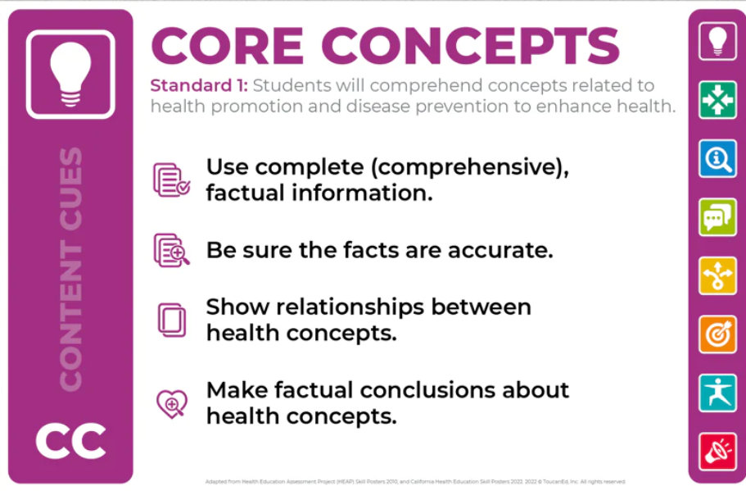 | 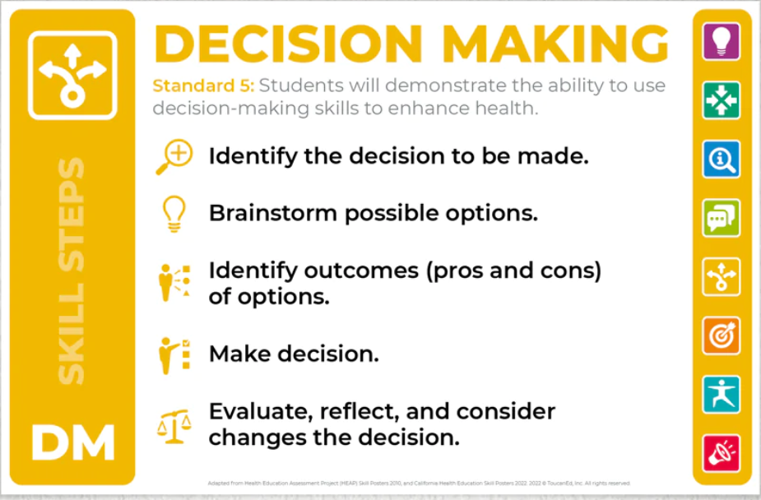
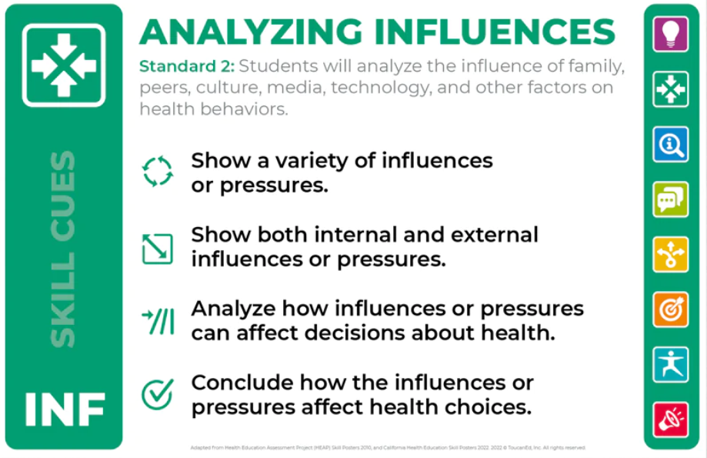 | 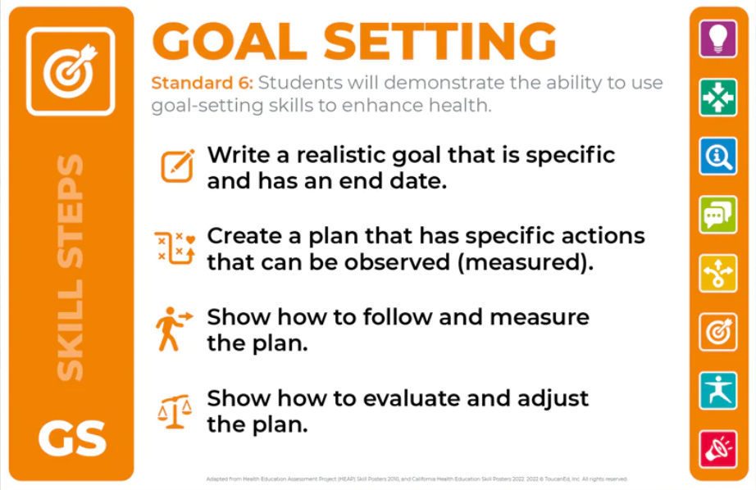
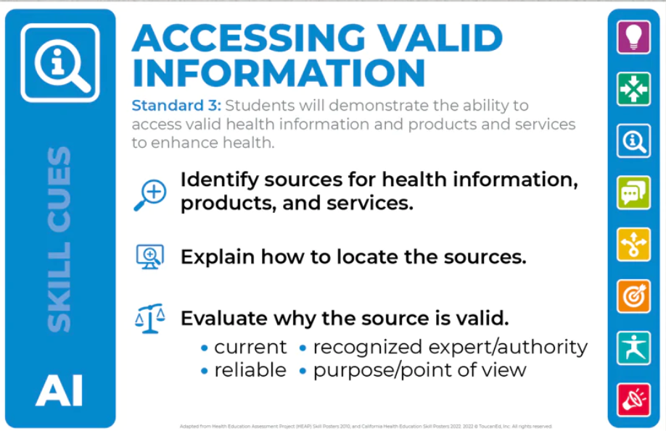 | 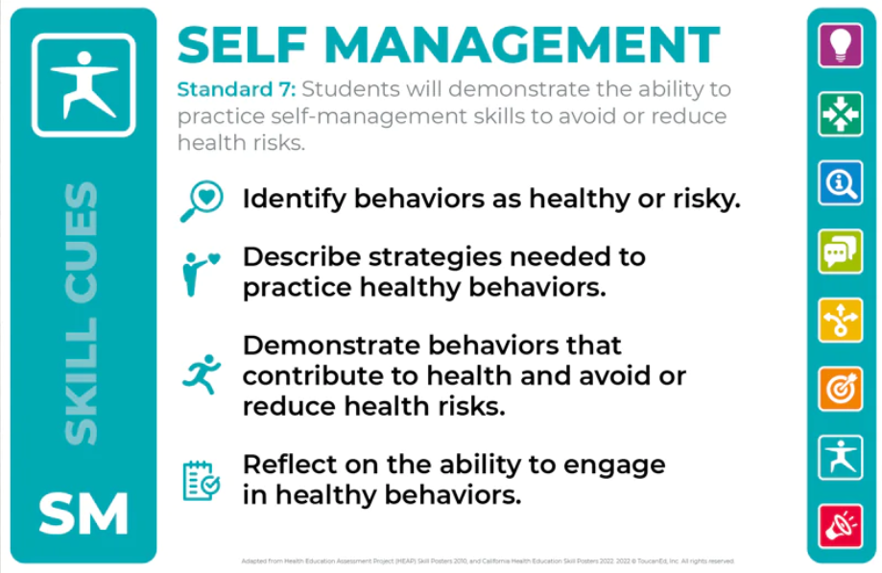
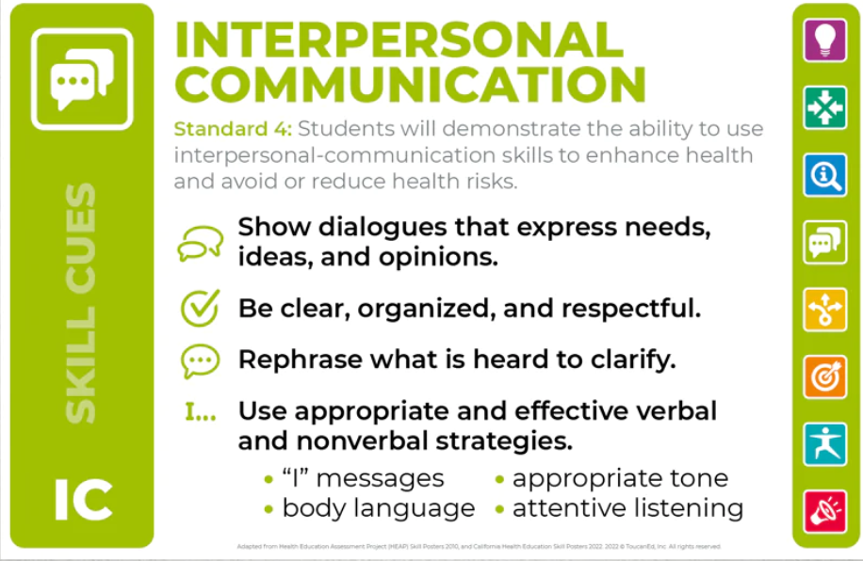 | 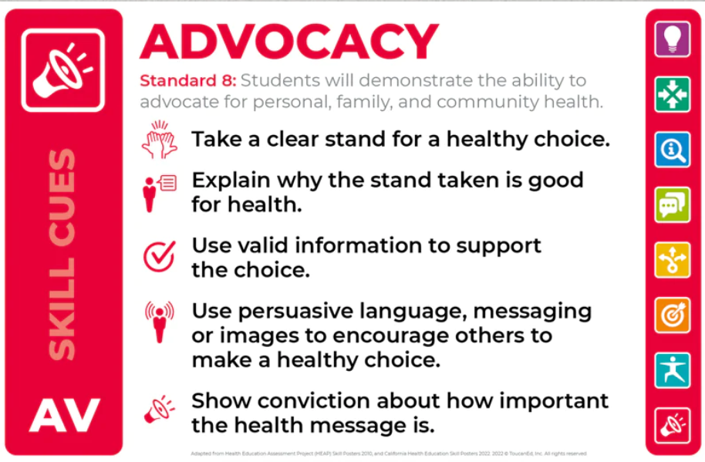
Part IV: Curriculum Mapping - The Health Education Core Concepts and Health-Literacy Skill Outcomes
Directions: Complete one document per X and O from Part II in the Curriculum Map Grid (yellow column). You can add and subtract rows in the tables as needed.
Grade Level:
Topic:
Number of Lessons:

Core Concept Outcomes: Standard 1

Health-Literacy Skill Outcomes: Standards 2-8
Standard # (2-8) | Health-Literacy Skill | Outcome

Suggested Activities:
Formative Assessments:
Summative Assessment:

