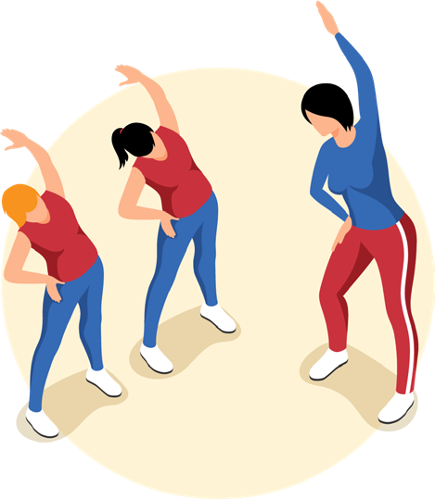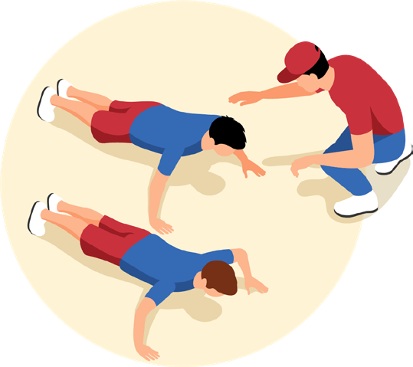

HEALTH AND PHYSICAL EDUCATION COLLABORATIVE
DATE:

**THE ZOOM LINK WILL BE SENT PRIOR TO THE TRAINING DAY.

TIME: 9:00AM-3:30PM
(REGISTRATION BEGINS AT 8:30AM)

COST: THIS TRAINING IS PROVIDED BY THE PENNSYLVANIA DEPARTMENT OF EDUCATION AND IS PROVIDED
AT NO COST

LUNCH: NOT PROVIDED
FACILITATOR:
REGISTRATION LINK:

PA HPE Program Improvement committee
and
Pennsylvania Department Of Education

This hands-on training will examine the proposed new skills-based standards that reflect current trends, practices, and concepts as well as appropriate terminology. Participants will be provided time to work with the new outcomes, applying them to areas in their own curricula, and will be aware of how the shift to skills-based standards will encourage all students to be lifelong and healthy learners.

This session also provides an in-depth training on the PA HPED Skills and Knowledge-Based outcomes. Participants will learn how to interpret
the outcomes then create a scope and sequence followed by a review of a sample health and physical education lesson plan.

