Curriculum Mapping – Health Education
Curriculum Map Grid
Part I: Number of lessons in Health - How many health lessons are taught at each grade level.
Grade Levels | K | 1 | 2 | 3 | 4 | 5 | 6 | 7 | 8 | 9 | 10 | 11 | 12
Number of Lessons

Part II: Identify Health Topics You Teach
- Use an (X) to mark all areas of the graph below to indicate the health topics you implement (left column for each grade level – yellow column).
- Put an (O) to mark all areas you would like to add to address the gaps in your curriculum (Left column for each grade level – yellow column).
- List the number of lessons for each topic area in the graph below l (right column for each grade level – white column).
Topics | K |  | 1 |  | 2 |  | 3 |  | 4 |  | 5 |  | 6 |  | 7 |  | 8 |  | 9 |  | 10 |  | 11 |  | 12
- Alcohol and Other Drugs

- Tobacco

- Healthy Rel/Sexual Health
- Healthy Eating
- Physical Activity
- Violence

- Safety

- Mental Health
- Personal Health

Part III: What Health Literacy Skills do you Teach?
Directions: Put a “Y” to indicate the health-literacy skills you teach in each grade level.

Health Literacy Skills | K | 1 | 2 | 3 | 4 | 5 | 6 | 7 | 8 | 9 | 10 | 11 | 12
Analyzing Influences (INF)

Accessing Information (AI)

Interpersonal Communication (IC)

Decision-Making (DM)

Goal-Setting (GS)

Self-Management (SM)

Advocacy (AV)

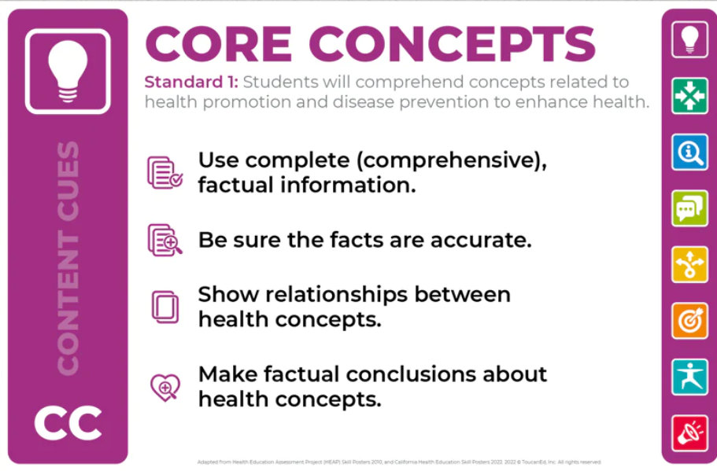 | 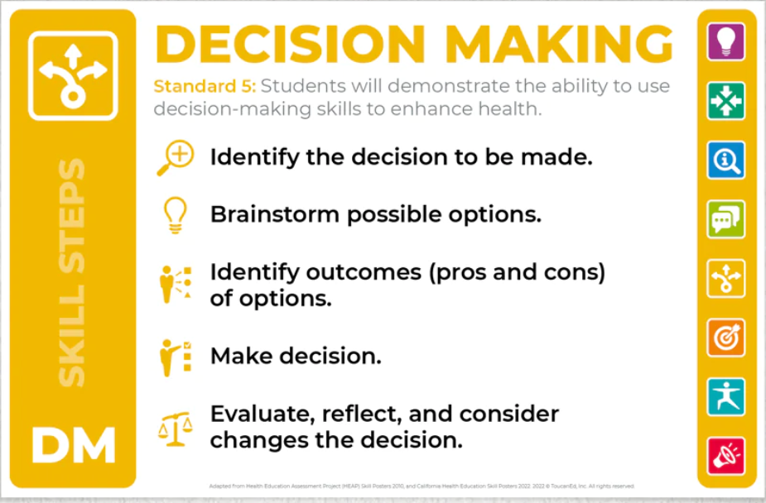
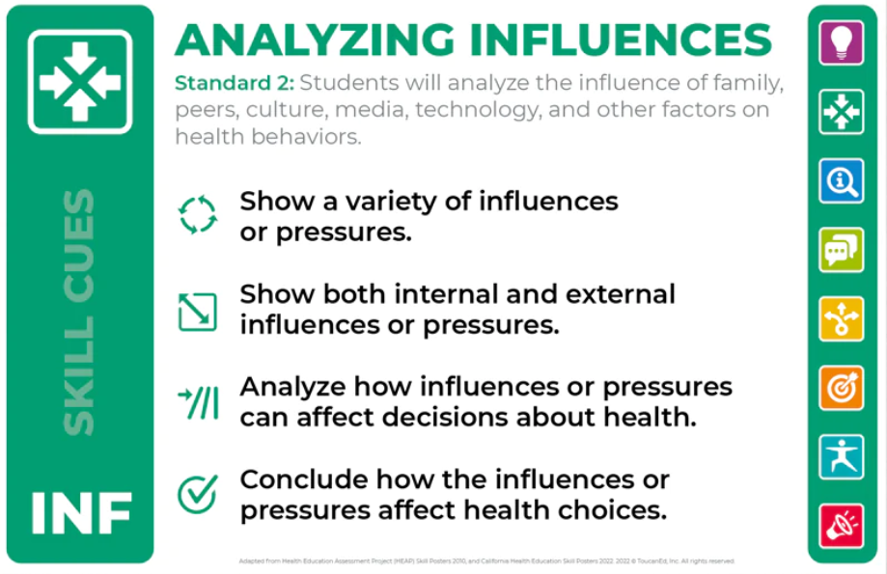 | 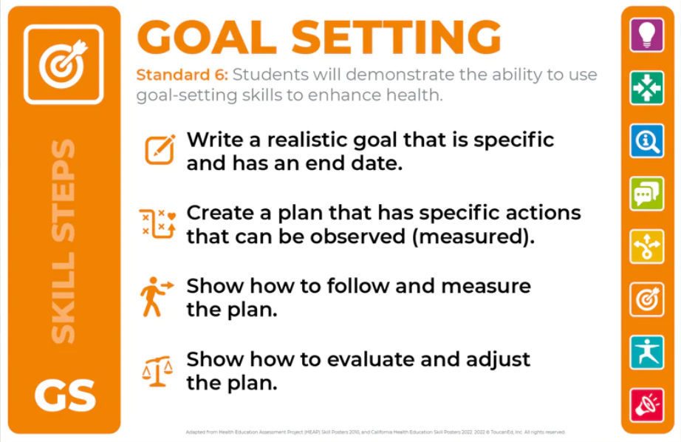
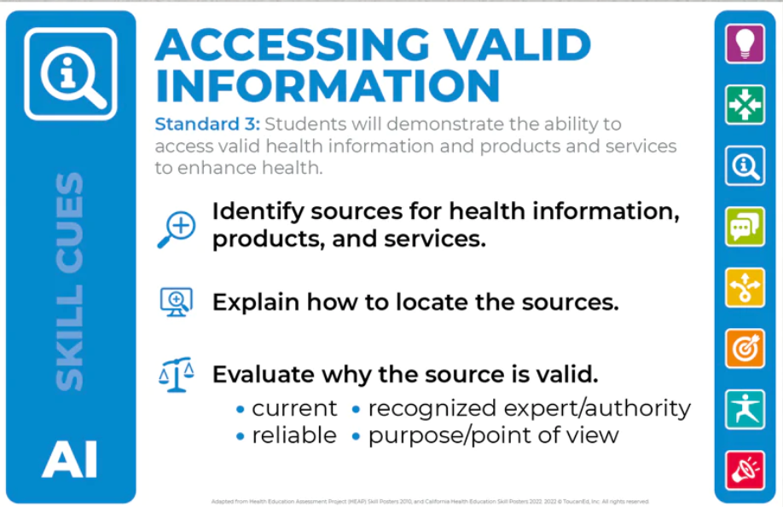 | 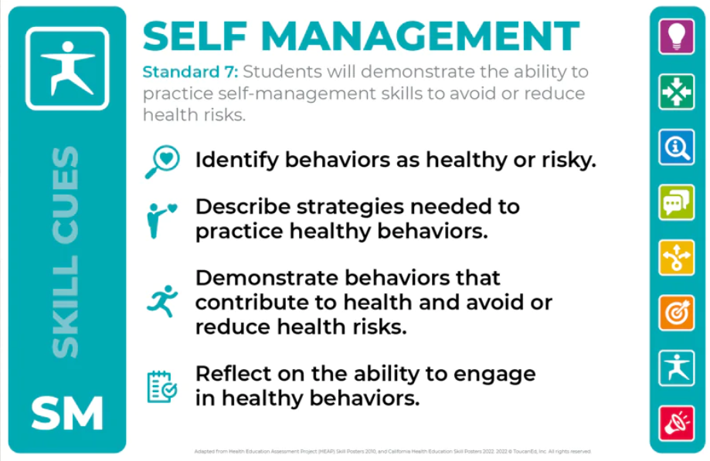
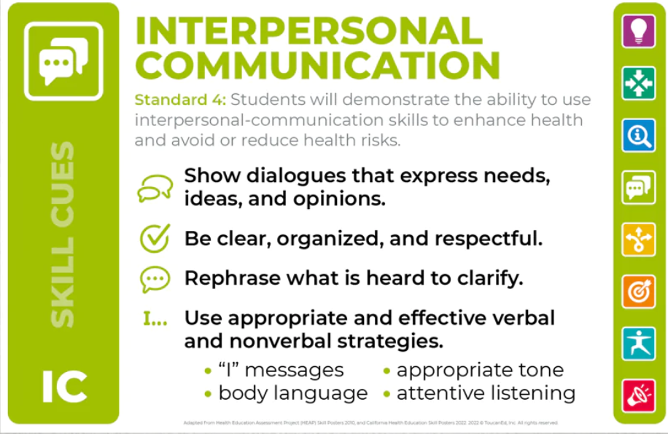 | 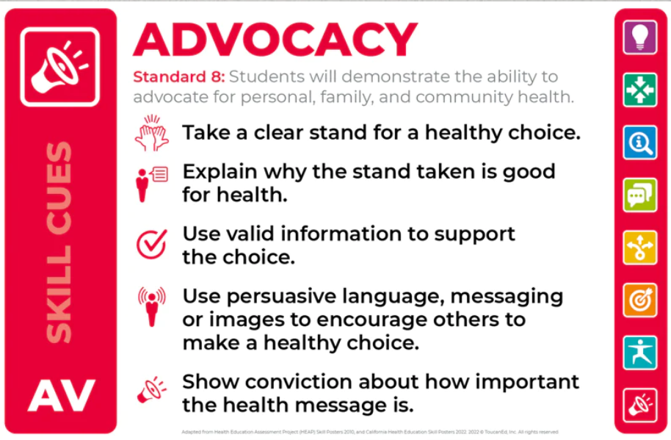
Part IV: Curriculum Mapping - The Health Education Core Concepts and Health-Literacy Skill Outcomes
Scope and Sequence
Health Education

- Grade Level(s):

- Choose the Health Topic:

- Choose Core Concepts Outcomes:
Core Concept Outcomes (Dark Purple Box #1)

- Choose Health Literacy Skills & Outcomes (List Health Literacy Skill for Each Outcome – Be Realistic):
Health Literacy Skill (Light Blue Boxes #2-#8) | Health Literacy Skill Outcomes

- Scope & Sequence of Core Concepts and Skill Outcomes – Sequencing Numbers 4 and
Lesson A
Core Concept Outcomes (Dark Purple Box #1)

Health Literacy Skill Outcomes

Lesson B
Core Concept Outcomes (Dark Purple Box #1)

Health Literacy Skill Outcomes

Lesson C
Core Concept Outcomes (Dark Purple Box #1)

Health Literacy Skill Outcomes

Lesson D
Core Concept Outcomes (Dark Purple Box #1)

Health Literacy Skill Outcomes

- Assessment: How do we know whether this student was successful?

Formative:
Summative:

